Being Real Being Light

A Lightwave experience incorporating the Basics Course from
Living Faith in Suffolk

What is Lightwave?
All over the county of Suffolk, there are churches with services each Sunday. Lightwave is a Christian community, meeting in small groups in homes, pubs, offices, schools and other places, which works alongside more traditional ways of doing church. The name comes from the idea of lightwaves being the way in which light spreads into dark places. Lightwave is committed to shining the light of Jesus in Suffolk through acts of kindness and practical service as well as worship and witness.
Lightwave groups do the essential things of church – but in a whole variety of different ways, suited to the needs of their members and the context of a small group who get to know each other well. So there are no sermons – but we read the bible and try to put it into practice in our lives. There may be no singing (unless the members are musical) but we find other ways to worship and pray for each other and our local community. We eat together and share the Christ-focussed meal often called “communion” or the eucharist. We have fun, support each other and try to put faith to work in practical care for friends and neighbours and the most needy in our society. Each group is part of the great wave of God’s love which brings light to our county.

Who can be part of Lightwave?
Anyone who wants to join one of our small groups. You do not need to be a Christian or have faith to be part of Lightwave - if you’d like to explore with us what it means to experience and speak God’s light in our communities that is enough. Having said that, many Lightwave members are also very active members of another church (most often Church of England but other kinds too) and find that being part of a Lightwave group helps them with the everyday putting faith into practice. Others would not be part of a church at all if it were not for Lightwave. Lightwave enable those who cannot get to a Sunday Service to be fully included in a community based on Christian faith. Our aim is also that people who find Sunday worship too formal or structured for them, especially younger generations and those unused to traditional forms of church, will find Lightwave to be somewhere where they can find friends to explore the journey of faith with them.

What happens in a Lightwave group?
They’re all different - but most meet weekly and follow the typical pattern used in these notes:
Welcome – time to chat and generally “catch up” over coffee or a meal. At some point an ice-breaker question or activity introduces the theme of the meeting. This gives everyone a chance to join in and gives a relaxed feel to the group.
Worship – time to focus on God and become aware of his presence, giving thanks, leaving behind the business of our day, and allowing him to touch and refresh us and realign our will to his.
Word – This is the Bible bit. We typically use discussion and activities to help us understand a passage or a subject. Our emphasis is practical – what difference will what we learn make to our lives?
Witness – Showing God’s love for our friends and neighbours. This includes praying for the needs of people, giving practical help and providing opportunities for people who want to explore faith. Many Lightwave groups will be the team for a fresh expression of Church such as Messy Church or Café Church which provides these opportunities.
Lightwave groups have a lot of fun together - barbeques, bonfires, Traidcraft parties, children's events, youth lazerquest, bowling or cinema. These are great times to invite friends and neighbours who might not normally feel comfortable to get involved with church events. From time to time worship and teaching events (county-wide or focused around one of our Rural Resourcing Churches) give all the small groups the opportunity to meet together.

Transforming Values
“The most important commandment,” said Jesus, “is this: ‘Hear, O Israel: The Lord our God, the Lord is one. Love the Lord your God with all your heart and with all your soul and with all your mind and with all your strength.’ The second is this: ‘Love your neighbour as yourself.””
Mark 12.29-31
These commandments reflect Jesus’ values – what was important to him: - a high view of God, a high view of others, a high view of ourselves, and sacrificial love. We believe that these values can be used to set a life-giving framework in which people can grow and help others to do the same. In Lightwave, they are reflected in a simple “rule of life” for the small groups:
All Involved – Everyone is included and valued, whoever they are. Everyone has a role to play.
Becoming Disciples – The purpose of the group is to encourage us to love and live more like Jesus.
Creating Community – We will “be real” with each other - honest about the things we go through ourselves and to respond in a loving way to each other. Caring for each other enables us to care for our wider community too.
Doing Evangelism – Being as well as telling good news together. Giving other people the opportunity to learn about Jesus (Not everybody likes the word ”evangelism” but really it is just about being the very best of good news for people in what we do and say – so we think it is important to understand this word – it does not involve bible-bashing!)
Encountering God – Meeting with God. It is God who helps us and changes us.
This introductory course takes us through this simple “rule” and seeks to explore how this can help us to “be real” and “be light” in everyday life.

Week 1: Being Real. Being Light. Taster Session

Welcome (15 mins)
If your group is meeting for the first time, introduce yourselves to each other - and get the facilitator to tell you a bit about the group and what it’s all about. For example, everyone is respected in a Lightwave group and if there is any activity or conversation which you don’t want to join in, it is fine to pass. Disagreement within the group is fine and normal - we learn more from each other when we share what we really think.

Introductory Question
(Good for over a cup of coffee)
What is the best (or worst) coffee you have ever had?
OR
If someone said that they thought it was important to “be real”, what would you take them to mean? (Do you think “being real” is important?)

Worship (15 mins)
Play some quiet music and take time to remember God is with you. Each light a candle as a sign of gratitude. As you light it name something or someone for which you are truly thankful.

Every good and perfect gift is from above,
coming down from the Father of the heavenly lights,
who does not change like shifting shadows.
James 1.17

Word (40 mins)
1. Start with a prayer, inviting God’s Spirit to guide your hearts and minds as you listen to the reading from the bible.
2. Begin with one person reading the bible passage below aloud to the group.
Matthew 5.13-16
“You are the salt of the earth. But if the salt loses its saltiness, how can it be made salty again? It is no longer good for anything, except to be thrown out and trampled underfoot.
¹⁴ “You are the light of the world. A town built on a hill cannot be hidden. ¹⁵ Neither do people light a lamp and put it under a bowl. Instead they put it on its stand, and it gives light to everyone in the house. ¹⁶ In the same way, let your light shine before others, that they may see your good deeds and glorify your Father in heaven.

3. Allow some silence to unfold as people let the words have their impact and to allow people to reread the passage to themselves again. All are invited to identify a word or phrase which stands out to them or speaks to their imaginations.
4. Find a person in the group you know least well. In pairs listen to each other as you tell each other the phrase which struck you and why. (Any reason is OK. There are no wrong answers here if it is real to you.)
Listen well, because your job will be to report to the rest of the group what your partner has said, not what you yourself said. Note-taking is OK.
5. Draw back together as a whole group and each tell what you learned from your partner.
6. Wrestle together as a group. Ask, “What might God might be up to in the passage for us today?”

Witness
In what ways are you currently part of being God’s salt and light in your community? Or what ways do you feel called to be salt and light in the future?
Offer these things to God in a time of prayer or silence

Finish with a prayer such as:
May the grace of our Lord, Jesus Christ and the love of God and the fellowship of the Holy Spirit be with us all evermore. Amen.

Share out leading different parts of next week’s session before you go

Week 2: Being Real. Being Disciples
Disciples” are not only followers (the most common definition) but also learners, apprentices. We can see this in the way that Jesus’ first disciples learnt by being alongside Jesus day by day, not only listening to his teaching but watching what he did and trying it themselves, and living his rhythms of life alongside him.

For the first disciples this apprenticeship entailed learning on-the-job, through observation, experience/practice, rhythms of life, learning - by living - what it means to live in the Kingdom of God. They did this as individuals and as part of a community.

“Whether poor or rich, male or female, free or slave, young or old – all were quite unbelievably loved and cared for each other. It was the lifestyle of the Christians that was witnessing.” (Desmond Tutu)
THOUGHTS AND QUOTES
This is Session 1 of the Basics Course of Growing Faith in Suffolk by Ruth Dennigan, adapted for a Lightwave or similar group

Welcome (10 mins)

Introductory Question
Tell each other something of your experience of being an apprentice or student.

Worship (15 mins)
Play some quiet music and take time to remember God is with you. Each light a candle as a sign of gratitude. As you light it thank God for guiding you with his Light.
I am the Light of the World
Whoever follows me will never walk in darkness
John 8.12

Word (50 mins)
1. Start with a prayer, inviting God’s Spirit to guide your hearts and minds as you listen to the reading from the bible.

2. RECEIVING: Begin with one person reading the bible passage below aloud to the group. Allow a silence of around two minutes, read the passage a second time, allow a silence of around five minutes, read the passage a third time. The periods of silence are for each participant to reflect on the passage, noting what stands out for them.
Acts 2.37-47
⁴² They devoted themselves to the apostles’ teaching and to fellowship, to the breaking of bread and to prayer. ⁴³ Everyone was filled with awe at the many wonders and signs performed by the apostles. ⁴⁴ All the believers were together and had everything in common. ⁴⁵ They sold property and possessions to give to anyone who had need. ⁴⁶ Every day they continued to meet together in the temple courts. They broke bread in their homes and ate together with glad and sincere hearts, ⁴⁷ praising God and enjoying the favour of all the people. And the Lord added to their number daily those who were being saved.
3. REFLECTING: After the third reading of the passage, give the participants to share and discuss what has struck them from the passage. A significant amount of time can be given to this discussion. Discuss:
THOUGHTS AND QUOTES
Early on (Acts 11:26) the rly church disciples became known as ‘Christians’ – this showed that they were Disciples of Christ, rather than disciples of anyone else.

As people share their discussions with the wider group, ensure people remember that: “community”, in this context, means growing with other Christians, but this can be wider than the local church: “Learning” is not only intellectual but also, for example, practical: “Worship” is not only in Sunday services but also, for example, in service to others: As an example, Town Pastors could be, for some, community as it forms a group of Christians who pray and serve together; for some it could be a learning experience; for some it could be a way in which they worship.
- What struck you during the time of looking at this passage?
- What did you notice; what did God seem to be saying to you/us?
4. RESPONDING: Today’s session aims to develop understanding of what is meant by “discipleship” and how this shapes the whole of life, to reflect on how participants currently live and grow as disciples and develop ways of furthering this, and to consider the Big Story of our faith and its impact.
Discuss:
- Who do we mean when we talk about “disciples”, “the disciples”, “being disciples”?
- What is a disciple?
- What did/does being a disciple entail? (See the sidebar for ideas.) Christians are disciples of Christ; therefore, we are disciples.
- How do you react to the idea that we are disciples, with all that entails?
The early disciples devoted themselves to the apostles’ teaching, fellowship, the breaking of bread and prayer – i.e. to learning community and worship. This was part of their witness which led to others joining them
Using the material, Being Disciples, on the next page (p.9)
- Reflect in pairs what “learning”, community and worship might mean and what they might look like in practice.
- In what ways do we currently devote ourselves to such things
- What else is part of the disciples’ witness (from the passage and your experience)?

Being Disciples

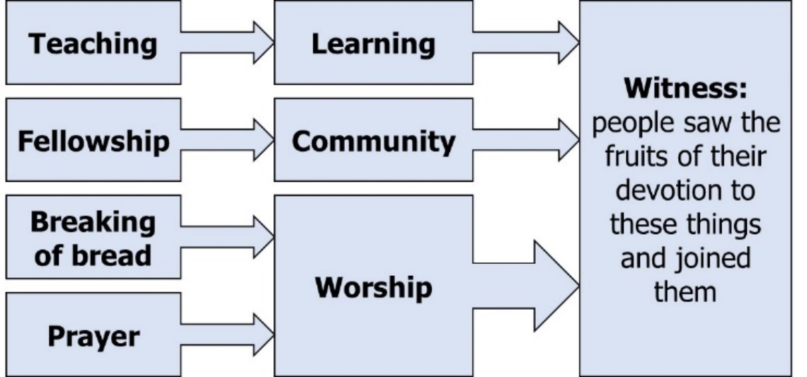

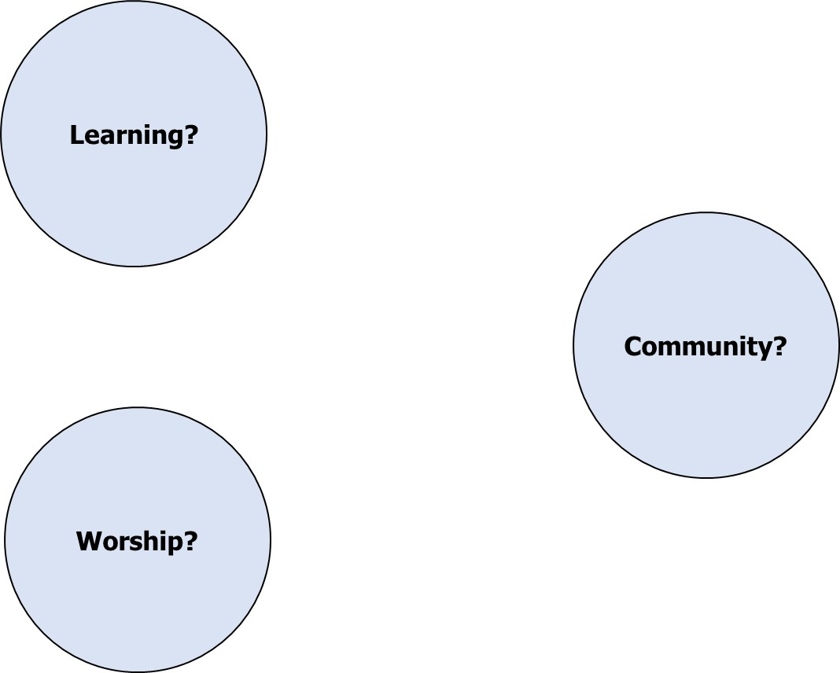
Individually, spend some time filling in the table below: Growing as Disciples. What else would you add to this list?

Growing as Disciples
 | This helps me to grow | Worth trying – it might help me to grow
Attending church/worship regularly
Trying to put faith into practice in daily life
Listening to sermons
Praying by myself
Music in church worship
My closest friendships or relationships
Participating in communion / Mass / Eucharist / Lord’s Supper
Being part of my church’s social life / fellowship
Reading / studying Bible by myself
Being part of a Bible study group
Being part of a missional small group/Lightwave group or similar
Reading Christian / spiritual / theological books (not Bible)
Seasons and shape of the Christian year
Conversations with people whose faith / beliefs are different
A familiar pattern of worship
Christian conferences, festivals, events or pilgrimages
Liturgy in church worship
Listening to Christian music (tape / CD / video / radio / online etc)
Experiencing different churches / Christian spiritualities
A particular person e.g. missionary, teacher
Direct call or experience I believe was from God
Spiritual director / mentor / soul friend / prayer guide
Hobbies, leisure or cultural activities not connected with church
Leading others (in worship, Sunday School, small group etc)
Listening to Christian teaching (tape / CD / video / radio / online etc)
A Christian course offered by a local church
Taking part in Christian outreach (e.g. evangelism, social justice)
Serving others
Going on retreat
Christian education from a college, university or denomination
Taking part in social justice / campaigning beyond church
Taking part in online discussions including social media
Adapted from: Foster, Simon What Helps Disciples Grow?
(St Peter’s Saltley Trust, Birmingham 2016)
Using the Card Sort on the next three pages (starting on page 12)
Telling the Big Story of Our Faith
Learning can take place in all sorts of ways; this idea behind this learning activity is to encourage people to think about some of the context and themes of our faith, and to inspire them to want to know more.
- Give out the set of cards from the next three pages (excluding the larger ones marked “Ten Commandments”, “Covenant”, “Temple” and “Prophecy”). Ask the group to put these cards into chronological order.
- When this is done (and amended as necessary – see page 15 for the key), ask the group to tell the stories of each character as far as they can.
- Put out the four remaining cards (“Covenant” etc.) and ask the group to put the character cards with whichever larger cards they think appropriate, so that characters are grouped around themes (e.g. they might decide that “Noah”, “Abraham” and “Jesus” all fit with “Covenant”), then ask the group to talk about these themes and explain their groupings.
- Discuss: How does this “Big Story” of our faith shape us?

Witness

In what ways are you, your small group or church sharing God’s story with those who don’t yet know it?
Why do you do this. What difference do you hope it will make?
Pray for these activities seeking God’s guidance and help

Finish with a prayer such as
May the grace of our Lord, Jesus Christ and the love of God and the fellowship of the Holy Spirit be with us all evermore. Amen.

Share out leading different parts of next week’s session before you go.

CARD SORT
Noah | David
Abraham | Solomon
Isaac | Elijah
Jacob | Isaiah
Joseph | Nehemiah

Moses | Ezekiel
Joshua | John
Deborah | Mary
Gideon | Jesus
Ruth | Peter
Samuel | Paul
Ten Commandments
Temple
Covenant
Prophecy

Correct order for card sort

Noah
Abraham
Isaac
Jacob
Joseph
Moses
Joshua
Deborah
Gideon
Ruth
Samuel
David
Solomon
Elijah
Isaiah
Nehemiah
Ezekiel
Mary
John
Jesus
Peter
Paul

Week 3: Being Called
This is Session 2 of the Basics Course of Growing Faith in Suffolk by Ruth Dennigan, adapted for a Lightwave or similar group

Welcome (10 mins)

Introductory Questions
- What do you understand by the phrase “being called”?
- Is there a difference between “calling” and “vocation” ?

Worship (15 mins)
Play some quiet music and take time to remember God is with you. Each light a candle as a sign of gratitude. As you light it thank God for calling you into his Light.

You are a chosen people, a royal priesthood,
a holy nation, God’s special possession
That you may declare the praises of Him
who called you out of darkness into his marvellous light
1 Peter 2.9

Word (50 mins)

1. Start with a prayer, inviting God’s Spirit to guide your hearts and minds as you listen to the reading from the bible.
2. RECEIVING: Begin with one person reading the bible passage below aloud to the group. Allow a silence of around two minutes, read the passage a second time, allow a silence of around five minutes, read the passage a third time. The periods of silence are for each participant to reflect on the passage, noting what stands out for them.

1 Corinthians 12.12-27
¹²Just as a body, though one, has many parts, but all its many parts form one body, so it is with Christ. ¹³For we were all baptized by one Spirit so as to form one body—whether Jews or Gentiles, slave or free—and we were all given the one Spirit to drink. ¹⁴Even so the body is not made up of one part but of many.
¹⁵Now if the foot should say, “Because I am not a hand, I do not belong to the body,” it would not for that reason stop being part of the body. ¹⁶And if the ear should say, “Because I am not an eye, I do not belong to the body,” it would not for that reason stop being part of the body. ¹⁷If the whole body were an eye, where would the sense of hearing be? If the whole body were an ear, where would the sense of smell be? ¹⁸But in fact God has placed the parts in the body, every one of them, just as he wanted them to be. ¹⁹If they were all one part, where would the body be? ²⁰As it is, there are many parts, but one body.
²¹The eye cannot say to the hand, “I don’t need you!” And the head cannot say to the feet, “I don’t need you!” ²²On the contrary, those parts of the body that seem to be weaker are indispensable, ²³and the parts that we think are less honorable we treat with special honor. And the parts that are unpresentable are treated with special modesty, ²⁴while our presentable parts need no special treatment. But God has put the body together, giving greater honour to the parts that lacked it, ²⁵so that there should be no division in the body, but that its parts should have equal concern for each other. ²⁶If one part suffers, every part suffers with it; if one part is honoured, every part rejoices with it.

Another word for “calling” is “vocation”. Although this has often been understood in a very narrow way (a vocation to ordained ministry, for example) this is not a true reflection of its meaning.

The idea of “calling” leads some people to feel uncomfortable. This can be because they associate it with a particular church tradition, a particular type of ministry or a feeling of being “put upon”. This is a subject which may need to be handled sensitively.

THOUGHTS AND QUOTES
²⁷Now you are the body of Christ, and each one of you is a part of it.

3. REFLECTING: After the third reading of the passage, give the participants to share and discuss what has struck them from the passage. A significant amount of time can be given to this discussion. Discuss:
- What struck you during the time of looking at this passage?
- What did you notice; what did God seem to be saying to you/us?

4. RESPONDING: Today’s session aims to develop awareness of calling as an essential part of discipleship, to consider the elements of this calling, to reflect on how skills and gifts have been developed and used in response to calling, and to be aware of the need to be listening for new ways in which this might occur.

Read the quotation below from Rowan Williams
God does not create human ciphers, a pool of cheap labour to whom jobs can be assigned at will. Each human being called into existence by him exists as a distinct part of a great interlocking web of identities. Each is a unique point in this great net. To be is to be where you are, who you are, and what you are — a person with a certain genetic composition, a certain social status, a certain set of capabilities.
From the moment of birth (even from before that) onwards, you will be at each moment that particular bundle of conditioning and possibilities. And to talk about God as your creator means to recognize at each moment that it is his desire for you to be, and to be the person you are. It means he is calling you by your name, at each and every moment, wanting you to be you.
We have to listen harder than ever — to each other and to our own hearts. And what emerges is perhaps that sense of near inevitability, that obscurely authoritative impulse that crystallises for some as “a vocation,” the sense that being myself will demand of me a certain kind of commitment.
(Rowan Williams https://www.trinitywallstreet.org/blogs/news/rowan-williams-your-calling-you)

Discuss:
- What are the key ideas in this quote? What might Williams mean by it?
- How do we react to this quote?
- How does this quote connect with our earlier reading from 1 Corinthians 12?

The Nature of Our Call
Our calling is four-fold: we are called
- to be disciples (a generic call which is given to all disciples) – see Jesus’ calling of his disciples in each Gospel (e.g. Mark 1:16-20, Mark 2:13-14, Luke 5:1-11 and John 1:35-51.)
- to be the body of Christ (a generic call which is given to all disciples) – see, in addition to the earlier reading, Ephesians 4:1-6
- to be holy (a generic call which is given to all disciples) – see 1 Peter 1:13-16
- by name (a specific call, an individual call to be ourselves – the best you that you can be – and to a specific role or task, which may be different at different points in our lives) – see for example Isaiah 43:1, Exodus 3:1-6, Acts 9:1-5.
Do some discussion, including Bible study, around these four elements, taking notes on the on the diagram on the following page if desired. If there are sufficient numbers, the group could be divided into four with each sub-group looking at one of the four elements. Useful questions for discussion could be:
- (looking at “to be disciples”) How do you react to the idea of being called to be disciples? How might this shape one’s perspective on discipleship?
- (looking at “to be the body of Christ”) How do you react to the idea of being called to be the body of Christ?
- (looking at “to be holy”) What do you understand by the calling to be holy as described in the reading from 1 Peter and in the box in the side bar? How do you react to this?
- (looking at “by name”) In what ways has God called you by name?

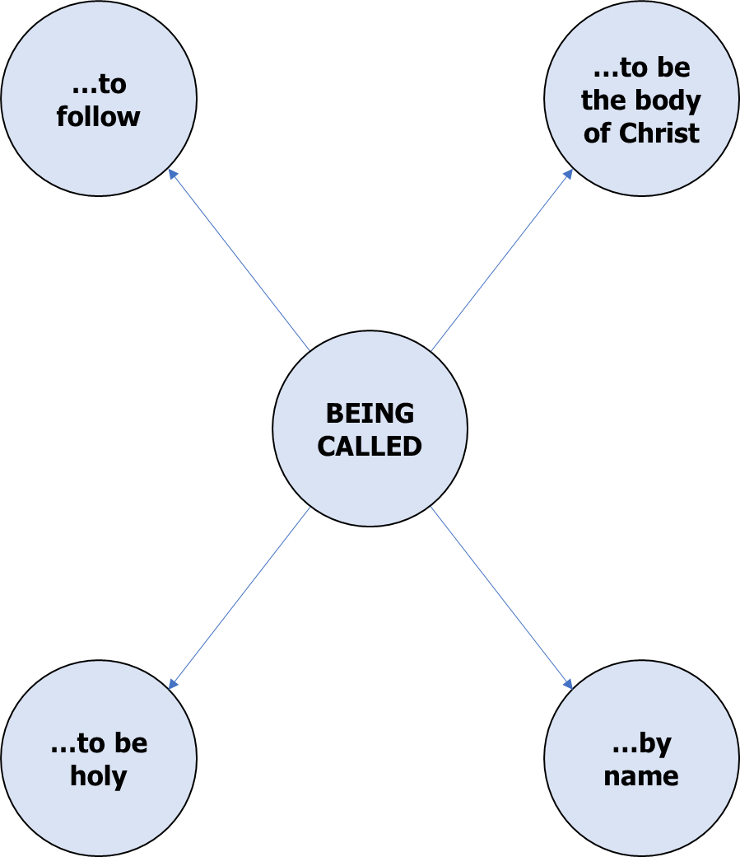

My journey
Each take a sheet of plain paper and draw your individual journey reflecting your story so far (it may be that this will need to be finished at home).
Think about:
- where have your gifts been used
- where have your gifts been developed
- where your journey may be taking you now
- Who are the companions on your journey (past, present, future)
If your group members know each other it could be useful, as part of this exercise, to reflect on each other (perhaps anonymously) – what you’re good at and what you are called towards. It can be hard for people to identify their own gifts and sometimes others see different things in us.

Witness
In what ways are you and your small group or church called to witness together?
Think of a practical example of a witnessing activity you have taken part in and talk about how different people’s gifts were used.
Identify or plan a witness activity which God may be calling you to as a small group. Pray about this.

Finish with a prayer such as
May the grace of our Lord, Jesus Christ and the love of God and the fellowship of the Holy Spirit be with us all evermore. Amen.

Share out leading different parts of next week’s session before you go.

Week 4: Working Together
This is Session 3 of the Basics Course of Growing Faith in Suffolk by Ruth Dennigan, adapted for a Lightwave or similar group

Welcome (10 mins)

Introductory Questions
- What is the best team you have ever been part of?

Worship (15 mins)
Play some quiet music and take time to remember God is with you. Each light a candle as a sign of gratitude. As you light it thank God for other people who have been a light to you?
“You (plural) are light for the world”
Matthew 5

Word (50 mins)
1. Start with a prayer, inviting God’s Spirit to guide your hearts and minds as you listen to the reading from the bible.
2. RECEIVING: Begin with one person reading the bible passage below aloud to the group. Allow a silence of around two minutes, read the passage a second time, allow a silence of around five minutes, read the passage a third time. The periods of silence are for each participant to reflect on the passage, noting what stands out for them.
Exodus 3.1-6
Now Moses was tending the flock of Jethro his father-in-law, the priest of Midian, and he led the flock to the far side of the wilderness and came to Horeb,the mountain of God. ²There the angel of the Lord appeared to him in flames of fire from within a bush. Moses saw that though the bush was on fire it did not burn up. ³So Moses thought, “I will go over and see this strange sight—why the bush does not burn up.”
⁴When the Lord saw that he had gone over to look, God called to him from within the bush,“Moses! Moses!”
And Moses said, “Here I am.”
⁵“Do not come any closer,” God said. “Take off your sandals, for the place where you are standing is holy ground.” ⁶Then he said, “I am the God of your father, the God of Abraham, the God of Isaac and the God of Jacob.” At this, Moses hid his face, because he was afraid to look at God.

3. REFLECTING: After the third reading of the passage, give the participants to share and discuss what has struck them from the passage. A significant amount of time can be given to this discussion. Discuss:
- What struck you during the time of looking at this passage?
- What did you notice; what did God seem to be saying to you/us?

4. RESPONDING: Today’s session aims to promote understanding of different models of working together
Using the cards on the following two pages - Relationships in ministry
- Cut out and give out the “Relationships in Ministry” cards from page 24 and seek to match the definitions and descriptions
- Using the key terms from page 24, discuss what each of these models might look and feel like in practice – consider where the power is – what kind of power is it? – what might it feel like to be in a church where this is taking place? – what is positive and negative about each model?

Reflect
On page 26, there are two quotations from the bible. The first talks about hiding from God. The second is about recognizing God around us. How are you tempted to hide from God in ministry? How can you recognize God all around?

“Earth’s crammed with heaven,
and every common bush afire with God;
But only he who sees takes off his shoes
The rest sit round and pluck blackberries.”
Elizabeth Barrett Browning
How does this extract from a poem relate to today’s bible reading and the discussion of collaborative ministry?
What steps might you take in shaping your shared ministry?

Relationships in Ministry

Definitions |  | Descriptions
Power  Solitary ministry |  | Unrelated to what parish needs/wants; all about a/each minister
Manipulation  Collusive ministry |  | Parish and minister[s] use each other to get what they want out of it
Instrumentalism  Delegated ministry |  | Parish and minister[s] each trying to please the other without rocking the boat
Mutuality  Shared ministry |  | Parish and minister[s] in it together, all have a part to play, all have gifts...
One ministry
Key terms
Power | Not collaborative |  | Non-consensual | Abusive
Manipulation | Not collaborative |  | Consensual | Pleasing yourself
Instrumentalism | Superficially collaborative |  | Contractual | Pleasing each other
Mutuality | Collaborative |  | Covenant | For the sake of the other (faithful relationship)
Union | Beyond collaborative |  | Sacrament | One flesh

Hiding behind the tree (Genesis 3:8)
In him we live and move and have our being
(Acts 17:28)

Witness
In what ways are you and your small group or church called to witness together?
Think of a practical example of a witnessing activity you have taken part in and talk about how different people’s gifts were used.
Identify or plan a witness activity which God may be calling you to as a small group. Pray about this.

Finish with a prayer such as
May the grace of our Lord, Jesus Christ and the love of God and the fellowship of the Holy Spirit be with us all evermore. Amen.

Share out leading different parts of next week’s session before you go

Week 5: Sustaining Ministry
This is part of Session 4 of the Basics Course of Growing Faith in Suffolk by Ruth Dennigan, adapted for a Lightwave or similar group

Welcome (10 mins)

Introductory Questions
- What energises you?
- What discourages you?
- What keeps you going when you are discouraged?

Worship (15 mins)
Play some quiet music and take time to remember God is with you. Each light a candle as a sign of gratitude. As you light it thank God for the way he enables us to see new perspectives.
For with you is the fountain of life; in your light we see light.
Psalm 36.9

Word (50 mins)
1. Start with a prayer, inviting God’s Spirit to guide your hearts and minds as you listen to the reading from the bible.
2. RECEIVING: Begin with one person reading the bible passage below aloud to the group. Allow a silence of around two minutes, read the passage a second time, allow a silence of around five minutes, read the passage a third time. The periods of silence are for each participant to reflect on the passage, noting what stands out for them.
Read Mark 1:29-39.
As soon as they left the synagogue, they entered the house of Simon and Andrew, with James and John. Now Simon’s mother-in-law was in bed with a fever, and they told him about her at once. He came and took her by the hand and lifted her up. Then the fever left her, and she began to serve them.
That evening, at sunset, they brought to him all who were sick or possessed with demons. And the whole city was gathered around the door. And he cured many who were sick with various diseases, and cast out many demons; and he would not permit the
In the morning, while it was still very dark, he got up and went out to a deserted place, and there he prayed. And Simon and his companions hunted for him. When they found him, they said to him, ‘Everyone is searching for you.’ He answered, ‘Let us go on to the neighbouring towns, so that I may proclaim the message there also; for that is what I came out to do.’ And he went throughout Galilee, proclaiming the message in their synagogues and casting out demons.

3. REFLECTING: After the third reading of the passage, give the participants to share and discuss what has struck them from the passage. A significant amount of time can be given to this discussion. Discuss:
- What struck you during the time of looking at this passage?
- What did you notice; what did God seem to be saying to you/us?
- Can you see evidence of anything which sustained Jesus in ministry?

4 RESPONDING: Today’s session and next look at three tools for the sustaining of ministry:
- theological reflection,
- being supported by others,
- being rooted in God.
This session involves an experience of theological reflection:

Choose a current issue – it could be local, national or international, such as a recent issue that has been in the news. Provide resources as stimuli if appropriate (e.g. newspaper headlines as a reminder of the issue). Spend around twenty minutes discussing:
- What, in the Bible and in our church tradition, might help us in knowing how to respond to this?
- What understandings of church and society emerge from this and how might we, as church community, respond to these?
- Pray about the issue in the light of God’s word.

Witness
In what ways are you and your small group or church called to witness together?
Think of a practical example of a witnessing activity you have taken part in and talk about how different people’s gifts were used.
Identify or plan a witness activity which God may be calling you to as a small group. Pray about this.

Finish with a prayer such as
May the grace of our Lord, Jesus Christ and the love of God and the fellowship of the Holy Spirit be with us all evermore. Amen.

For next time – Try to fill in the table overleaf on page 31:

Getting the Balance – Living by a Simple Rule
(taken from document of the same name by Canon Alan Hargrave, former Canon of Ely Cathedral)

What do you actually do every day, week, month, year to sustain and grow: | Every day | Every week | Every Month | Every Year
1. Your relationships with loved ones, family and close friends?
2. Your relationships in your church community?
3. Your relationships with work colleagues, neighbours and wider community?
4. Your spiritual life / relationship with God / your own soul?
5. Your own personal health and well-being?

Week 6: Rule or Rhythm of Life
This incorporates part of Session 4 of the Basics Course of Growing Faith in Suffolk by Ruth Dennigan, adapted for a Lightwave or similar group

Welcome (10 mins)
Divide into 2 groups and give each person a pencil and paper. Give the members of one group a ruler as well. Give them 3 mins to draw squares 5cm by 5cm compare the results of the 2 groups
Read this aloud
The word “rule” conjures up images of school and dreary regulations. But a Christian “rule of life” is not that sort of thing. A “Rule of Life” is a framework for freedom – deliberately chosen habits and customs which we have chosen because they help us to live God’s way more closely. One of the most famous and far reaching Christian “rules of life” is that of the sixth century St Benedict of Nursia which remains the joyful heartbeat of the Benedictine Order to this day. This rule and many others were written in Latin: The Latin word “regula” means rule in the sense of a straight edge for measuring and drawing lines…. Like the ruler, in the welcome activity, It helps us to accomplish what we want without getting wobbly! The other meaning of the word “regula” is a regular rhythm – a chosen rhythm of life brings freedom rather than restriction, a practical way of seeking God more authentically and living more fully and joyfully for him. All growing Christian disciples have a rule of life although they may not know that this is what it is called. Consciously developing a Rule or Rhythm of Life helps us to be intentional about the way we live, being proactive in deciding what our priorities will be and to help us develop good habits.
Discuss
Have you ever heard of the idea of a “rule of life” before?
Can you think of any deliberately chosen priorities, habits and rhythms in your life which help you follow Christ more closely? (If you have difficulty answering this look at the “Duties of church membership” overleaf – you may find that some of the things in it are part of your rule too!)

Worship (15 mins)
Play some quiet music and take time to remember God is with you in your every day. Each light a candle as a sign of gratitude. As you light it thank God for the way he lights each step of your path.
Your word is a lamp unto my feet and a light unto my path
Psalm 119:105

Word (50 mins)
Start with a prayer, inviting God’s Spirit to guide your hearts and minds as you study from the bible.

Jesus’ rhythm of life.
- What do you think might have been distinctive about how Jesus would do one of the following:

- Wake up in the morning
- Greet those he would see first thing in the morning
- Eat
- Drive
- Work
- Shop
- Use the Internet
- Watch TV
- Go to bed at Night

- Make a list of some of the habits and practices which Jesus kept to keep him close to his heavenly Father.
The following bible verses may help you find some of the less obvious things Jesus did:
Mark’s Gospel Chapter 1 verses 35-39-44, 41; Chapter 2 verses 5, 16, 18-21; Chapter 3 verses 1-6; Chapter 4.38; Chapter 5 verses 30-32; Chapter 9.50; Chapter 10 verses 16, 45; Chapter 14 verse 12, 26, 32; Chapter 15 verse 5.
Matthew’s Gospel Chapter 4 verses 1, 4, 7, 10; Chapter 5 verses 3-11, 20, 33-37, 39-42, 44; Chapter 6 verse 31
Luke’s Gospel Chapter 2 verses 41, 46, 49, 51
John’s Gospel Chapter 13 verses 5, 14, 34.

My rhythm of life.
Share the thoughts you had about your rule of life in your home-work

A Shared Rhythm of Life
“There is one body and one Spirit… The gifts he gave were… to equip the saints for the work of ministry, for building up the body of Christ, until all of us come to the unity of faith and of the knowledge of the Son of God, to maturity, to the measure of the full stature of Christ.”
Ephesians 4:7, 11-13
Being rooted in God is essential for any Christian involved in ministry – but this is not a solitary thing. Human beings are made for community – to support and challenge each other, to work and play together, to laugh and cry together. Many Christians share a Rule of Life – this can be a simple one such as the 5 Lightwave values:

- All Involved
- Becoming Disciples
- Creating Community
- Doing Evangelism
- Encountering God
Or it can be much more involved such as the famous Rule of St Benedict (see page 35)

Discuss
- Why is the support of others important?
- How has working with others enriched your ministry and life?
- How is being with others reflected in your rhythm of life?

Witness
As you come to the end of this course, share how God has been working in your life during the time of the course and what your intention is in terms of having a rhythm of life – as an individual and shared with others to sustain you in your ministry.

Finish with a prayer such as
May the grace of our Lord, Jesus Christ and the love of God and the fellowship of the Holy Spirit be with us all evermore. Amen.

EXTRA MATERIALS FOR SESSION 6

A NOTE ON SPIRITUAL STYLES (David Cainos)

Our preferred spiritual styles shape the way in which we make sense of our experiences of God and life, and the way we express what is important to us. It is possible to learn to work with any style but we will engage more deeply with some than with others. It is useful in ministry, to recognise that others may find things helpful in their spiritual growth that we find less helpful and vice versa.
Word-centred people value thinking. They learn about God and grow spiritually through spoken and written words. Preaching, Bible study, clearly-articulated beliefs and rational argument are important to them. The words that are used are crucial – they need to be properly thought-out and carefully chosen. These people may like to participate in the reading – or writing – of words used in the service. Learning is important.
Emotion-centred people value feelings. They learn about God and grow spiritually by getting in touch with their deepest emotions. The performing arts (music, dance and drama), close personal relationships, the experience of conversion and testimony all feature in their spiritual world. They may like to be actively involved in church worship and to be able to discuss their experiences.
Symbol-centred people value images, symbols and metaphors. They see God as the ultimate mystery, beyond all human understanding. They look to nature, art, silence and meditation to open up the reality of God for them. They may like being alone with God. They are likely to be uncomfortable with the use of lots of words.
Action-centred people focus on justice, healing and social transformation. Their relationship with God is lived rather than spoken or felt. They express their faith in what they do, both in their involvement in church activities and in their daily life, listening for the cries of the poor and identifying with the needs of the world. They are likely to be uncomfortable with the use of lots of words, and with thinking conceptually as they prefer concrete actions

Living by a Rule of Life

The Iona Community
http://iona.org.uk/movement/the-rule/
Members share a common Rule which includes:
- Daily prayer and reading the Bible
- Mutual sharing and accountability for our use of time and money
- Regular meeting together
- Action and reflection for justice, peace and the integrity of creation
The Northumbria Community
http://www.northumbriacommunity.org/who-we-are/our-rule-of-life/
The Rule we embrace and keep will be that of AVAILABILITY and VULNERABILITY.
- We are called to be AVAILABLE to God and to others: seeking him, exercising hospitality caring for others
- We are called to intentional, deliberate VULNERABILITY: being teachable through prayer, study of Scripture and accountability to others; speaking out when necessary; living openly amongst unbelievers and believers as a church without walls.
The Benedictine Rule
http://www.benedictfriend.org/the-rule.html
- Stability: the importance of community and commitment in life
- Conversion: acknowledging that God converts continually, and being open to this
- Obedience: cultivating a disciplined life that is obedient to God
The Rule revolves around five practices: Prayer, Work, Study, Hospitality and Renewal.
The Community of Etheldreda
http://www.elycathedral.org/worship-music/cathedral-groups/rule-of-life
- Listening: to God, through the Bible, silence, retreats, others, prayer and corporate worship
- Obedience: the Latin root means ‘to listen intently to God’, letting it shape life
- Stability: belong and be content within a stable Christian community, living together in love
- Work: reflect God’s creative activity, including practical service, for the benefit of all
- Transformation: commit to being open to being changed by God’s love and grace in order to realise potential and become more Christ-like

“When a rule of life is successful it has served as a kind of ‘scaffolding’ to build into us a life that flows from us naturally in the pressure cooker of life.”
Jim Baker http://sacredstructures.org/movement/a-rule-of-life-changing-the-way-we-live/

