We’re really excited at HOPE because Hope for Every Home is launching OIKOS, a new prayer walking app. You can find it free on your app store under OIKOS Outreach or just click our weblink Hope for Every Home : The Prayer App
Hope for Every Home is part of HOPE Together supporting local churches and Christians to share the good news about Jesus with our communities…to the last home. The OIKOS app is all about reaching every home through prayer.
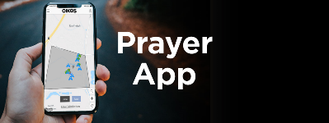
During Covid and lockdown God has taken his church out of the building, reconnected people with local people through our daily walk. Now the invitation is to turn the daily walk into a prayer walk, to pray for every street, every road, every lane in the UK over the next year. This means mobilising Christians all over the country to pray, not as an extra but as part of every day, as we go to school, to work to the shops…we can pray as we walk or even as we drive or sit. Simply download the OIKOS app and tap your phone screen to tag a prayer.
Would you help us create a movement covering the UK in prayer? Download OIKOS, pray for your street and share this e-mail with your networks.
Join the conversation by following us on Facebook: hope4everyhome We’d love to hear what happens when we invite God into the conversation on a national scale!

