Labours of Love
Practical Sessions
inspired by the Rule of Benedict
for Small Groups
who want to make a difference in their community

Lent 2021
Ideal for Zoom or similar platforms

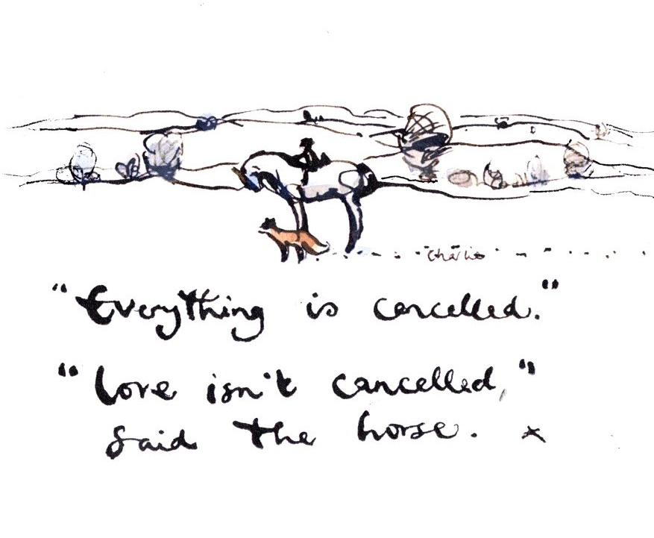
Small group notes for use in the Diocese of St Edmundsbury and Ipswich, written by Sally Gaze in collaboration with the Lightwave Community, Suffolk and St Edmundsbury Cathedral. Version 3c.
The translation of the Rule used in these notes is ‘The Rule of St Benedict as used at Burford Priory, now Mucknell Abbey, 2002.
Illustrations are from The Horse the Boy, the Fox and the Mole by Charlie Mackesy published by Ebury Press

Contents
Page
Introduction
3 40 days of Kindness – A practical initiative for Lent 2020
4 Introduction to Benedictine Spirituality
5 Getting started
Six Sessions for Small Groups
6 1 Listen
8 2 Pray
10 3 Live
12 4 Love
14 5 Come
16 6 Humble

Appendices
18 Sample Community Invitation
19 Extra/Alternative Activities for Each Session
24 About the Lightwave Community
25 Being a Small Group Facilitator
26 Lectio Divina and Dwelling in the Word
28 The Prayer of Examen
29 Meditation
30 How to Develop a Personal Rule of Life
33 Further Resources

40 days of Kindness: Lent 2021
We start Lent 2021 living with Covid Restrictions, although at the time of writing we do not know whether they will ease to some extent during the month. In any case we will be living with a world in which our options to be together are limited. Even when restrictions ease, it may be that some people will be left behind in the rush to grasp a semblance of a “normal” life. Loneliness will still be a big issue in our county.
As Christians with churches and small groups in every community in Suffolk, we have a chance to live the message “Love isn’t cancelled.”
There are still opportunities to care for and with each other even in the context of lockdown or social distancing. 40 Days of Kindness is a Suffolk-wide initiative of the diocese of St Edmundsbury and Ipswich to facilitate and publicise neighbours working together across our county within the restrictions: using phone, internet, relay-working and more we can show what the Love of the Gospel message looks like in action. The Lightwave Community and the Cathedral will be facilitating partnership and help, especially when needs or requests seem bigger than a single community can handle.
This Labours of Love course was written specifically to help Christians in a small group to support each other, pray, serve and gently share faith through this 40 Days of Kindness in Lent. It is however possible to take part in the practical initiative without undertaking the course.
We warmly commend 40 Days of Kindness to you. It is flexible to meet the circumstances of your area and our dream would be for there to be loving neighbours making a difference in this simple way in every benefice of our diocese.

Introducing Benedictine Spirituality
Benedict of Nursia was born in 480 and was a student in Rome. Tiring of the decadent culture around him, he withdrew to live as a hermit in the countryside east of the city. Others, looking for a meaningful way of life, came to join him and he started a monastery. He wrote “the Rule” to order and guide life in the monastery but many people 1500 years on are still benefitting from its wisdom.
The Rule of Benedict was written at a time when the Roman Empire was in decline, with a deteriorating economy, great social injustice and the rich living on the backs of the poor. Therefore, it needed to establish norms for community living. It goes into practical detail about how members of his community are to conduct themselves, to enable mutual relationships and genuine respect for each other, irrespective of background, as well as emotional and spiritual growth. Benedict calls the monastic way of life “a school for the Lord’s service.” Although some of the language and concepts may seem old-fashioned and extreme to us, many find in the “school” wisdom for living together in our world today, 1500 years later, outside monastery walls as well as within.
‘Therefore, we intend to establish a school for the Lord’s service. In drawing up its regulations, we hope to lay down nothing that is harsh or burdensome. The good of all concerned, however, may prompt us to a little strictness in order to amend faults and to safeguard love. Do not be daunted immediately by fear and run away from the road that leads to salvation. It is bound to be narrow at the outset.
‘But as we progress in this way of life and in faith, we shall run on the paths of God’s commandments, our hearts overflowing with the inexpressible delight of love.’
From the Prologue of the Rule of Benedict
The Benedictine way is often said to be summed up in the Latin phrase Ora et Labora – “pray and work”. It is about holding those two things in balance. In its millenium year, the cathedral has sponsored two courses both of which seek to hold prayer and work together.
The first “Run with Joy” especially emphasises the prayerful reading of Scripture through the Benedictine practice of lectio divina. It offers doorways for learning and further reading about the Benedictine tradition. It seeks for prayer to flow into work.
This “Labours of Love” course was written specifically to help Christians in a small group to support each other, pray, serve and gently share faith through the 40 Days of Kindness initiative. It is designed to be accessible to people with less experience of Christian faith. It seeks for work to flow into prayer.
Both courses can be adapted for Zoom or for in-person meeting. “Run with Joy” will take place on Tuesday and Thursday evening and Wednesday afternoons in Lent. You can sign up to join at www.light-wave.org/lent and download the participants notes as a pdf.
“Lent Labours of Love” is ideal for you to run locally and the notes are downloadable in editable form so that you can more easily change them as you need for your situation and context. You can download them from www.light-wave.org/lent
I hope you will join with us in this in this anniversary of the Benedictine foundation of our cathedral.

Getting started with 40 Days of Kindness
1. Listen and Pray – It is not too late if you haven’t already started to plan your acts of kindness at the beginning of Lent. Listening and prayer are in themselves a kindness. The first session in the Labours of Love series will help you to listen by helping you think who you could ring, how you could ask the questions or make your availability known in your local area.
2. What you do will be locally determined as well as determined by the situation with the pandemic. There is a huge range of possibilities. Here are some things which are happening in various places to get you thinking – but listen locally and be guided by your own situation:
- Welcome packs for new housing
- Help a refugee family to find basic furniture
- Phone tree to build relationships in a village
- Taking rubbish to the tip for a person with restricted capacity
- Painting a fence, mowing a lawn or other outside work which can be done by one person or people socially distanced
- Packed lunches for children off school
- Thankyou hamper for the local school or doctors’ surgery
- Voluntary delivery service to help a local shop
- Pop-up shop
- Church-porch pantry or food bank
3. What to do if you get a request / encounter needs which are beyond your capacity. It is good to set up an expectation that you will help where you can but not to guarantee anything until you’ve had time to explore how you can help. The Lightwave team or the cathedral community will support you / help you to find partners to work with you whenever we can.
Contacts: Lightwave Staff Team – lightwave.community@cofesuffolk.org
Graham Miles (Lightwave Rural Chaplain) – tel. 07413 683368
Matthew Vernon (Canon Pastor at the Cathedral) – canon.pastor@stedscathedral.org
4. The value forming a small group to engage in 40 Days of Kindness together. Forming a small group will enable you to share insights and possibilities as well as problems and solutions. It also makes it easier to pray together, learn together and see how serving in a community connects to the life of faith. The “Labours of Love” notes are designed to help small groups to do all of this.
All in all, you will be able to make more difference in the world and grow more in your own faith if you work together with others. And it will be fun!

1 Listen
““This is my dearly loved Son, who brings me great joy. Listen to him.”
Word from the bright cloud at the transfiguration of Jesus: Matt 17.5 (NLT)

“Listen carefully, my child, to the guidance of your teacher.
Listen carefully to it with the ear of your heart.”
Prologue to the Rule of Benedict
“The first duty of love is to listen” Paul Tillich
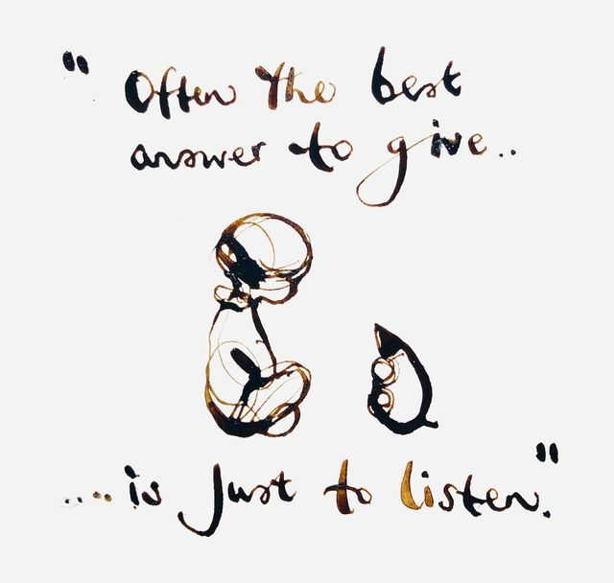

WELCOME
As it is the first time of meeting, take a little time to introduce yourselves and agree any ground rules, confidentiality etc. Then, to get you thinking about listening, each seek to briefly answer one of the following questions.
Who is the best listener you know and why?
How does it make you feel when somebody listens deeply to you?

WORSHIP
God is the great listener. Thank God for listening to us
Make some time to listen to him.
For example, use the words which Eli told Samuel to say to God, “Speak Lord, your servant is listening.” Then play some quiet music and seek to receive anything God might want to show you.
OR Use the shortened form of Examen in the Extra Activities for this session

WORD
Read Luke 15.1-2 & 11-32
Verses 1-2
Jesus tells this story to respond to a situation where some are listening. Who is listening to him and who is not?
Verses 11-32
What signs of listening / paying attention are there in Jesus’ story and what effect has this had on the characters?
The story ends on a cliff-hanger. How might the situation change for a) the younger son and b) the older son depending on their listening to what the Father is saying?
Applying the story
What do you think the outcasts and religious leaders will hear as the message for them if they are listening to Jesus’ story?
What do you think God may be saying to you through this passage?

WITNESS
Engaging in 40 Days of Kindness presents lots of opportunities to listen to people and to what God is doing in the lives of our communities. Discuss and pray about what you are doing: How can you recognise and take the opportunities to listen?
Examples:
MISSION INSIGHT
Listening is essential to loving.
As Christians serving as part of a local community, we are called to...
- Listen to God through prayer
- Listen to the people of God, local and global
- Listen to people where we live, work and serve – hopes, fears, needs and joys
- Listen to and be aware of ourselves – our own feelings and experiences
In the study of Christian mission, this is sometimes called 360 degree listening because we are listening all around.

1. If you have not yet sent out an invitation in your community, look at the samples in the appendices and discuss how you could do this in a way which encourages personal contact through phone calls and opportunities to listen.
2. If you have already sent out an invitation, share the responses so far and discuss what you can learn from them about people’s thoughts, feelings, needs and dreams and what God might be saying through this.
3. 40 Days of Kindness is not just about getting useful tasks done – but about the love and community that can be created through the contact this facilitates. Pray and plan together how you can plan for Covid-safe contact through your practical labours of love together – e.g involving people by phone or zoom – working outside within waving sight of one another.
2 Pray
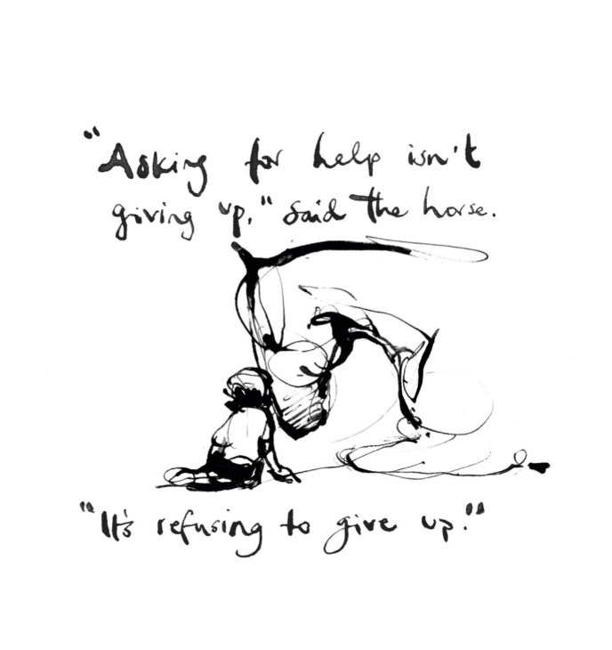
“Ask and it will be given to you; seek and you will find; knock and the door will be opened to you… If you… know how to give good gifts to your children, how much more will your Father in heaven give the Holy Spirit to those who ask him!”
Jesus teaching his disciples
in the Gospel of Luke, Chapter 11
“This is the beginning of my advice: begin everything you attempt
with the earnest prayer that it will be brought to completion.”
Prologue to the Rule of Benedict
“Our prayers will not be heard for our many words, but because of our purity of heart and tears”
Rule of Benedict, Chapter 20

WELCOME
To get you thinking about praying, each seek to briefly answer one of the following questions:
As far as you are able, say something to the group of what prayer means to you?
Is praying hard or easy?

WORSHIP
It is not uncommon for people to feel that they "ought" to engage in acts of kindness or “labours of love”. While such work is a calling which we should take seriously, duty isn’t our main motivator: God sent Jesus because he loved the world (John 3.16) and Jesus willingly obeyed because he loved us (John 15.13).

Love is our main motivator.

Spend some time praising God for his love.

For example, listen to a song or hymn on a YouTube clip which reminds you of God’s love or repeat the examen from last week but particularly noticing where you have experienced God’s love this week.

WORD
Read Mark 9.14-29
THEOLOGICAL INSIGHTS
“Until a man gets faith, he may think that he has got it, but when he gets real faith in Jesus Christ, then he shudders as he thinks how long he has lived in unbelief, and realizes how much of unbelief is still mixed with his belief” Charles Spurgeon, Sermon 2881 on Mark 9.24
“God hardly gives his Spirit, even to those whom He has established in grace, if they do not pray for it on all occasions… God does nothing but in answer to prayer; and even they who have been converted to God without praying for it themselves, (which is exceedingly rare) were not without the prayers of others. Every new victory which a soul gains is the effect of a new prayer” John Wesley, A plain account of Christian Perfection, Ch 11
“Total dependence on God is the remedy for many spiritual problems. To be disappointed in yourself is to have trusted in yourself.” David Guzik, Enduring Word Bible Commentary on Mark 9

Verses 14-22
It could well be that we might describe the son’s illness as a form of epilepsy today, but do not spend too long discussing this: It could distract from the main point that the disciples had been unable to help before Jesus arrived.
How do you think the disciples, the scribes and the family in need were feeling about this situation?
Verses 22-29
What do you think is the relationship between faith and being able to be instruments of God’s love and healing?
Have you ever wanted to pray like this desperate father, “Help my unbelief”?
Prayer and fasting do not make us more expert or deserving to drive out demons or to serve God in any way. Why then, are they so important?

Pray
- Pray for all those you are seeking to serve through 40 Days of Kindness and for yourselves as you work together as a group. (Using what you learned through your listening activities last week, make a list of those you want to pray for and use it each time you meet for the rest of Lent.)
- Pray for your faith to grow – and pray this also for those on your list.
- Pray that God will enlarge your heart of love for the people he is calling you to care for.

WITNESS

1. If you have not already done so, share with each other what you have learned through your listening activities last week. Pray and decide on the actual “labours of love” you will participate in together – or about how any existing plans may change or be added to.
2. Challenge each other to practice a rhythm of prayer in the coming week, in which you stop several times during the day to pray. There are some ideas to help you in the Extra Activities section. Next week ask each other how you got on.
3. End the meeting by praising God for the community you are serving and all you are learning as you seek to work together.
3 Live
“The most important commandment… is this: ‘Hear, O Israel: The Lord our God, the Lord is one. Love the Lord your God with all your heart and with all your soul and with all your mind and with all your strength.’ The second is this: ‘Love your neighbour as yourself.’
There is no commandment greater than these.”
Words of Jesus from St Mark’s Gospel, Chapter 12

“A serious Christian, set down for the first time in a Christian community, is likely to bring with him a very firm idea of what Christian life together should look like… But God’s grace speedily shatters such dreams.”
Dietrich Bonhoeffer, Life Together,

“When a monk is to be received, he promises…
commitment to community,
ongoing conversion through the shared way of life and obedience.”
Rule of Benedict Chapter 58 (own paraphrase)

WELCOME
Today’s session is about living life together in community and how the ups and downs of a shared life provide the workshop within which God shapes us in his service:
Which groups/ communities/ families do you belong to?
What difference have they made to your life?

WORSHIP
Each light a candle to represent your thankfulness for someone who brings light into your life. As you do so, speak their name (“Thank you Lord for N”)
Say together this Lenten canticle which reminds us how our common life is based on the forgiveness we receive through Christ’s suffering on the cross. (If on Zoom, allocate different verses to different voices):
A Song of Christ the Servant
1 Christ suffered for you, leaving you an example, ♦
that you should follow in his steps.
2 He committed no sin, no guile was found on his lips, ♦
when he was reviled, he did not revile in turn.
3 When he suffered, he did not threaten, ♦
but he trusted himself to God who judges justly.
4 Christ himself bore our sins in his body on the tree, ♦
that we might die to sin and live to righteousness.
5 By his wounds, you have been healed, for you were straying like sheep, ♦
but have now returned to the shepherd and guardian of your souls.
Based on 1 Peter 2.21b-25 from Common Worship: Daily Prayer © The Archbishops' Council 2005.
WORD
BENEDICTINE INSIGHT
St Benedict, founder of Benedictine monasteries, did not expect great feats of prayer or mysticism from the monks. In his rule, they are challenged to set out on a path to change their hearts. This he called conversatio morum – a term difficult to translate.
Conversatio indicates a kind of conversation. The Latin in the Rule is sometimes rendered conversio which means conversion or transformation. Morum indicates that this is about change of behaviour or of a way of life. So conversatio morum is about ongoing intentional action to seek God truly and grow into the likeness of Christ through the ups and downs of life lived together in community.
It is part of the 3-fold vow made by every Benedictine monk – stabilitas (life-long commitment to the community), conversatio morum (conversion of life) and oboedientia (loving obedience).

Read Luke 6.27-36
Engage in the practice of “Dwelling in the Word” using this reading. See the notes in the appendix on page 26.
For further discussion
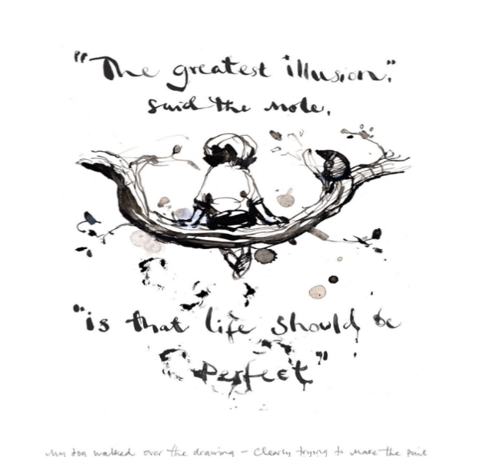
Read the Benedictine insight on the right. How have the ups and downs of your relationships at church or in a small group helped you to enable us to learn to live a life of love in the real world?

WITNESS
1. By now you will have decided on one or more “Labours of love” that you will take part in as a group.
Pray
- Pray for all those you are seeking to serve through Lent Labours of Love and for all those you put on your group’s Lent prayer list last week.
- Pray for yourselves as you work together as a group.
- Pray that God will enlarge your heart of love for the people he is calling you to care for and for each other

.
2. Last week you had a challenge to practice a rhythm of prayer in which you stop several times during the day to pray. How did you get on? What did you learn by doing this – about others, about God, about yourself? (Spend 5-10 minutes talking in pairs about this.)
3. End the meeting by praising God for the community you are serving and all you are learning as you seek to work together.

4 Love

“By this shall all know you are my followers – that you love one another”
Words of Jesus from John 13
“If you love me, you will obey my commandments”
Words of Jesus from 14
“Your way of acting should be different from the world’s way;
the love of Christ must come before all else”
Rule of Benedict Chapter 4
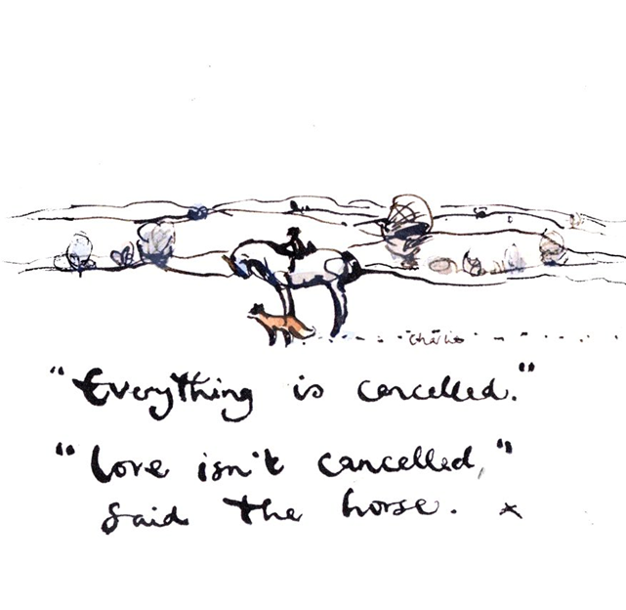
WELCOME
Today is about the character of Christian love. Christians are commanded to love God and their neighbour – so it is clearly something other than just a feeling. To get the group thinking, each have a go at answering this question:-
What do you think Love is ?

WORSHIP
Say these words from aloud:
This is love: not that we loved God, but that he loved us
and sent his Son as an atoning sacrifice for our sins.
(1 John 4.10)
Play “Love each other” by G Kendrick (https://www.youtube.com/watch?v=2MblrWZDpPQ) or a similar song. As you listen, take a candle but this week let it privately signify somebody whom you know well but find it difficult to like – Light the candle and let God’s love shine on this relationship: Silently thank God for this person and His love for them..

WORD
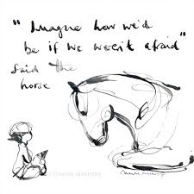
Read 1 John 4.18-21
Engage in the practice of “Dwelling in the Word” using this reading. See the notes in the appendix on page 26
For further discussion
1 Can you think of any good thing you would do differently if you were not held back by fear?
2 How do you think Love overcomes fear? Try to give each other some examples of where you have seen this happening.

WITNESS
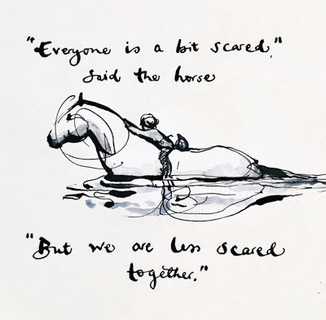
1. How are your labours of love going together? Have any of you found yourselves doing things which you would have been afraid to undertake on your own?
Pray
- Pray for all those you are seeking to serve through 40 Days of Kindness and for all those you put on your group’s Lent prayer list last week.
- Pray for yourselves as you work together as a group.
- Pray that God will enlarge your heart of love for the people he is calling you to care for and for each other and that his perfect love will cast out fear.

.
2. How are you getting on with your rhythm of prayer? What are you learning learn by doing this – about others, about God, about yourself? (Spend 5-10 minutes talking in pairs about this.) This week, continue or modify your rhythm of prayer and try to make a list of the habits you have developed or are trying out to help you to love God and others.
3. End the meeting by praising God for His Love, the community you are serving and all you are learning as you seek to work together.

5 Come…
“Come to me, all you who are weary and burdened, and I will give you rest.
Take my yoke upon you and learn from me, for I am gentle and humble in heart,
and you will find rest for your souls. For my yoke is easy and my burden is light.”
Jesus words from the Gospel of Matthew, Chapter 11
“It is a way which seems narrow at first.
But, as we progress in the life of conversion and faith,
with heart enlarged and love beyond expression,
we will run with joy the way of God’s commandments.”
Prologue to the Rule of Benedict
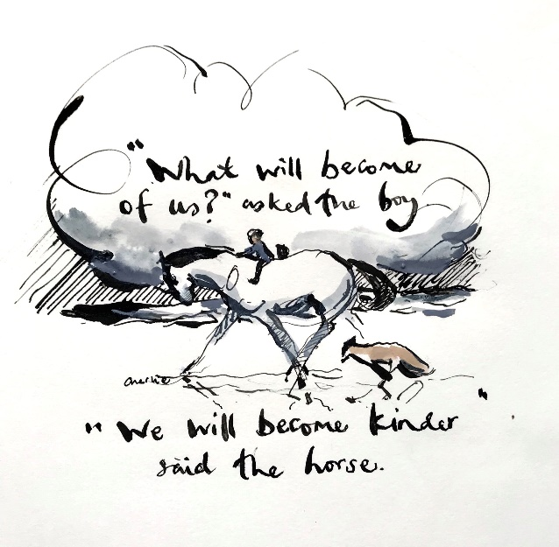

WELCOME
Today we are thinking about Christian habits – sometimes called “Christ’s yoke” or “rule of life”. To get you thinking about habits, each seek to briefly answer at least one of the following questions.
What would you regard as one of your good habits?
What difference has this habit made in your life?

WORSHIP
Meditate on Matthew 11.28-30
Play some quiet music, read the passage and deliberately still yourselves to “dwell” upon Jesus’ invitation to find rest in him.
As the music ends one of the group can quietly thank Jesus for his rest and refreshment.
WORD
THE EASY YOKE
A yoke is a frame put on the shoulders of an ox which has some weight in itself – but which makes the carrying of otherwise impossible burdens or the pulling of a plough so much easier. This is especially true when oxen are yoked together and share the weight. Dallas Willard reminds us that Jesus’ acts of love, healing, wisdom and self-sacrifice are impossible without such a yoke. To take on the yoke of a rabbi was to participate in the habits they practiced - for Jesus, habits that would be called a “Rule of Life” by Christians today – habits like prayer and study, silence and service, thanksgiving and celebration:
“We cannot behave “on the spot” as Jesus did and taught if in the rest of our time we live as everybody else does…
The secret of the easy yoke, then, is to learn from Christ how to live our total lives, how to invest all our time and our energies of mind and body as he did. We must learn how to follow his preparations, the disciplines for life in God’s rule that enabled him to receive his Father’s constant and effective support while doing his will.”
Excerpted from Dallas Willard’s The Spirit of the Disciplines (pp.7,9). HarperOne (New York, 1998).

Read “The Easy Yoke” right
Jesus’ rule of life.
1. Make a list of some of the habits of Jesus which you remember from the gospels.
And/or
2. How do you think Jesus would…
- Eat
- Drive
- Work
- Spend the weekend
- Shop
- Use the internet
- Watch TV
- Go to bed at night

My Rule of Life
What habits do you think can be most helpful in forming a Christian “Rule of Life” today?
Commit to working on a draft personal Rule of Life this week or share one thing that you will do as a result of thinking about Jesus’ rule of life – and pray for each other about this.
WITNESS
1. How are your labours of love going together? Is anything you are doing becoming a shared good habit?
2. Spend some time in silence listening
- for guidance about how you can make the invitation of Jesus to come to him more accessible and visible to those you serve – maybe an Easter invitation?
- Share what you hear with each other

3. Pray
- Pray for all those you are seeking to serve through the 40 Days of Kindness and for all those you put on your group’s Lent prayer list last week. Pray for them to accept the invitation of Jesus “Come to me all who are weary and burdened and I will give you rest.”
- Pray for yourselves as you work together as a group that you will be yoked together by the easy yoke of Christ and that God will continually increase your love for others.
- End the meeting by praising Jesus for his Easy Yoke.
6 Humble
“The Son of Man came not to be served but to serve
and to give his life as a ransom for many.”
Words of Jesus in the Gospel of Matthew, Chapter 20
Divine scripture calls out to us saying, “Anyone who lays claim to a high position
will be brought low and anyone who is humble will be lifted up.”
The Rule of Benedict Chapter 7, quoting Luke14.1 & 18.14
“True humility Is not thinking less of yourself: It is thinking of yourself less.”
C S Lewis
“When we make ourselves God, no one in the world is safe in our presence.
Humility…is the basis for right relationships in life.”
Joan Chittister – Introduction to the Rule of Benedict

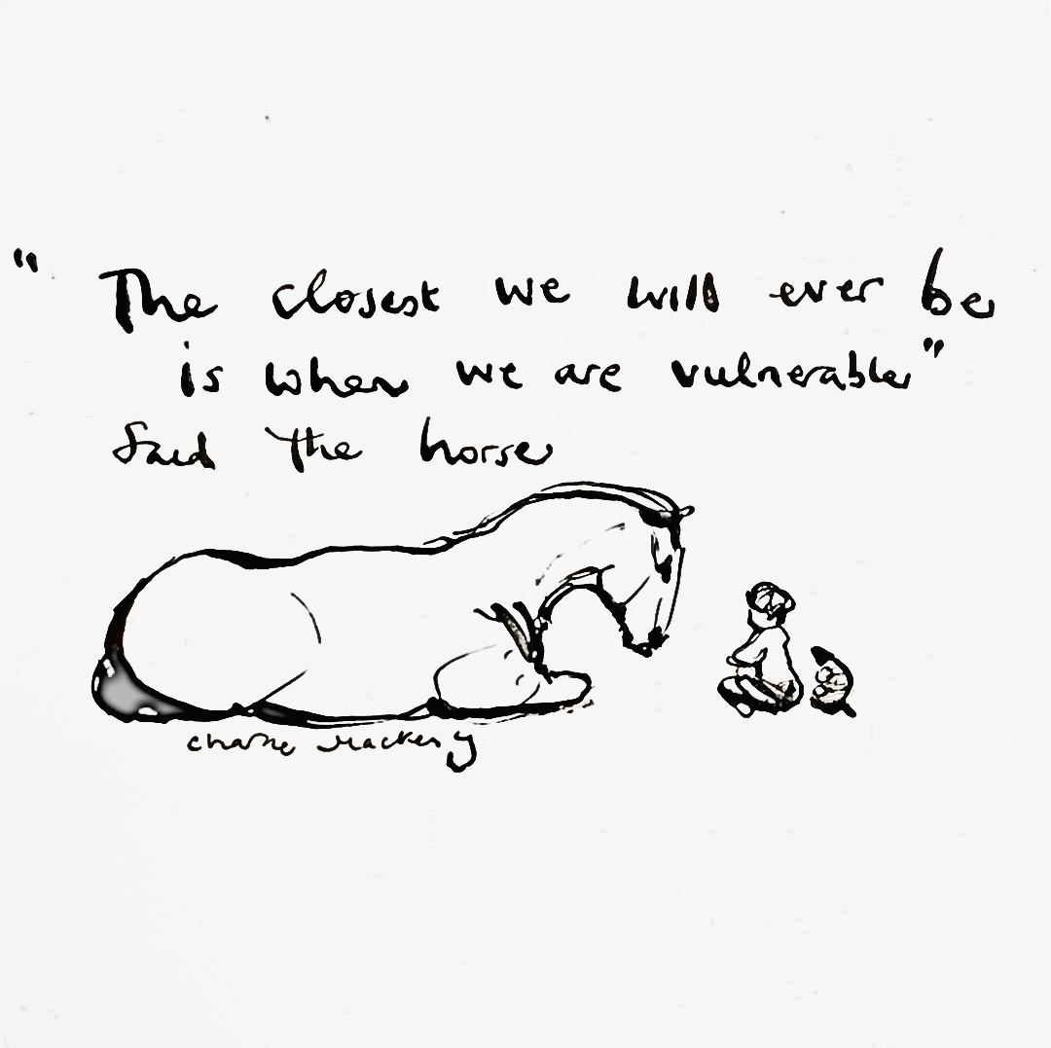
WELCOME
Today we are thinking about humility. Think of a situation when you felt you did not receive the recognition you deserved. Consider these questions and each share something of your thoughts with the group:
What did you do?
What did you think and feel afterwards?
What would be the healthiest / most loving response?

WORSHIP
Focus on praise and thanksgiving – that Jesus came humbly to serve and to give his life. You could play Graham Kendrick’s “The Servant King” or Matt Redman’s “Light of the World” or one of the many songs and hymns about the cross to help you to focus on Jesus and what he has done for us.
WITNESS
Serving is key to humility.
1. Spend some time in silence listening
- How have your practical labours of love been going?
- What have you learned?
- What needs and opportunities have you found out about?
- What steps is God calling you to next?
- Share what you hear with each other.

2. Pray
- Pray for all those you are seeking to serve through 40 Days of Kindness and for all on your group’s Lent prayer list. Pray for them to know the love of Christ crucified and the joy of resurrection
- Pray for yourselves – as you go your separate ways or pray and plan what God might be calling you to together after Easter

WORD
Humility is widely misunderstood today as putting yourself down or a lack of self-respect. In fact, it is more about having a grounded perspective on the world and our place within it. It means being secure enough in ourselves not to need to compete, so we can be attentive towards the claims of others as well as our own.
Read Mark 9.33-37
BENEDICTINE INSIGHT
Benedict devotes a whole chapter to humility in his rule of life – in it he pictures Christians on a ladder – on this ladder we ascend towards Christ when we take a lower place and serve others, and descend away from God when we strive for recognition. Humility is important to Benedict because it is foundational to close community: it is as we see ourselves as fellow sinners, all deeply loved and forgiven by our heavenly Father that we begin to offer each other compassion in our weaknesses and are thankful for each others strengths.
Examples of humility include:
- Doing something to help without seeking for others to know about it
- Celebrating the strengths and successes of others
- Refusing to be drawn into unhealthy criticism of others
- Saying sorry
- Receiving criticism without defensiveness
- Missing out on recognition without getting resentful
- Caring for the planet even when this is unseen
Engage in the practice of “Dwelling in the Word” using this reading. See the notes on how to do this in the appendix on page 26.
For further discussion
1 If you have worked on your personal Rule of Life this week, feed back in an appropriate way – maybe in pairs.
2 Which of the examples of humility in the blue box do you find the most difficult? Pray for each other in your struggles in this area.

End with spoken prayers
of thanksgiving
for the Love of God
and for each member
of the group

APPENDICES
1. Sample Community Invitation

You can adapt this invitation to include your own contact details and what you can offer locally– It could be communicated through a letter or card delivered to each house, a Facebook page or a community magazine – or a combination of these and other ideas appropriate to your community.
You are warmly invited to
______________________’s
INSERT NAME OF YOUR CHURCH OR GROUP ABOVE
40 Days of Kindness
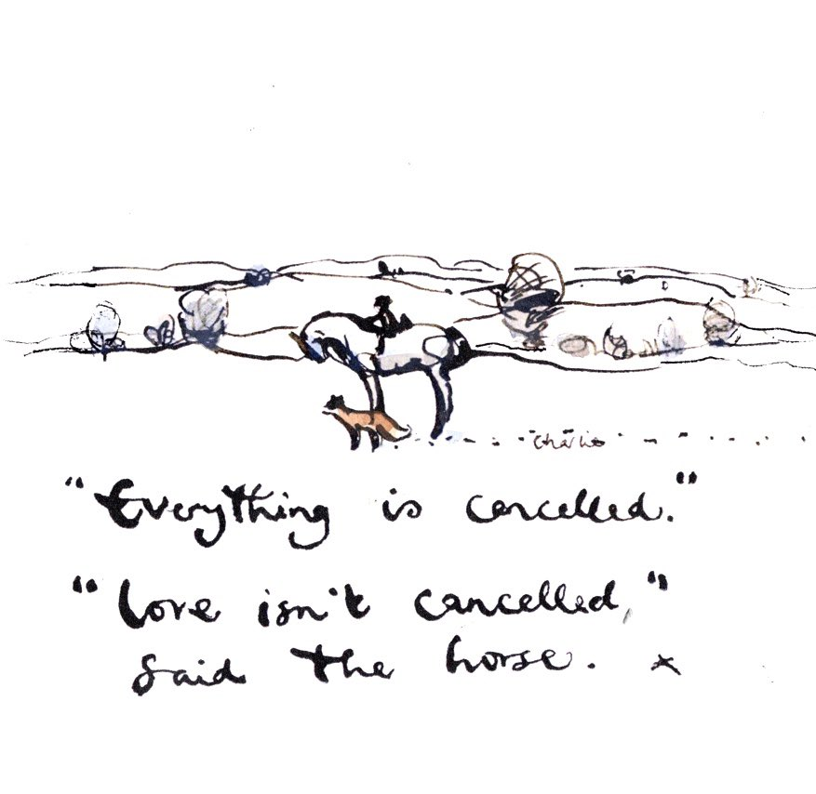
NAME OF CHURCH/GROUP invites you to keep Lent with us by making it a time of helping each other with acts of love and kindness
The idea is not only to help each other with some of those jobs we cannot do alone, but also to build relationships with each other as we continue to live through Covid-19. We will do this using Covid-safe ways through phone calls and socially distanced ways of serving You can take part by asking for a job to be done for you, contributing an idea for something that needs doing in the community or offering to help with a job. Do not feel you have to be desperate to make a request – helping each other out, helps our whole community to grow closer.
Please fill in the form below and put it in the box at the surgery or shop to offer or request help OR you can keep this form for your own information and ring/text INSERT NAME on INSERT NUMBER
I would like help with…

Garden tidying
Taking items to the tip
Taking items to a charity shop.
Shopping/ Medicine Collection
Other_____________
I would like to offer help with

Shopping
Garden / Churchyard tidying
Taking items to tip/ charity shop
Litter picking
My name and contact details so that you can contact me to make arrangements _______________________________________________________________________________________________

2. Extra/Alternative Activities for Each Session
1 LISTEN extra
- You can find an example invitation letter on page 18 of the Appendices.
- Here is a shortened form of examen to use as part of worship together. Examen is a way of reviewing your day in the presence of God
  - Invite God to guide you in remembering your week and hold silence together
  - Notice times when you can see God at work – perhaps moments of love and grace. Silently give thanks for the many gifts you have received as well as those you shared.
  - Invite the group to pray one sentence thankyou prayers out loud about these moments: “Thank you God for Sunday’s dinner”
- Watch the story of Taste and See on the Expressions DVD 1 (You can borrow from the diocese/MSM course). Pool your ideas on how listening in different directions plays a part in the story.
- Make a list of examples from the Old and New Testaments of people listening/ researching before embarking on something God wants them to do.
- An important part of Benedictine Spirituality is the practice of Lectio Divina – listening to God through the slow reading of Scripture. Look up more about Lectio Divina on page 26 and try it by yourself or in your group.
- This week, individually make a point of listening to people, make time for: a stranger who would welcome a listening ear; a family member, a friend, or an acquaintance.
At the end of the day, take a couple of minutes to note down who you listened to, or if someone blessed you through their listening. Say a prayer for them.

2 PRAY extra
- Shortened form of examen which could be used as part of worship together. Examen is a way of reviewing your day in the presence of God
  - Invite God to guide you in remembering your week and hold silence together
  - Notice times when you have seen God’s love this week. Silently give thanks
  - Invite the group to pray one sentence thank you prayers out loud about these moments: “Thank you God for your love shown in the phone call”
- Part of this week’s witness challenge is to practice a rhythm of prayer in which you stop several times during the day to pray. The length of these prayer times can vary. Here are some ideas to help you –
  - Set your phone alarm to a specific daily time. When you hear it, stop to pray the Lord’s prayer.
  - Ask a friend to do this with you so that you encourage each other - maybe phone each other to pray.
  - Use an app such as Daily Prayer App, prayer.com, Lectio 365, Inner Room, Sacred Space (Irish Jesuits), WCCM app, Common Worship Daily prayer, Taize Daily Prayer (Google – it takes you to the daily prayer on the website),

3 LIVE extra
i) Notes on the Benedictine approach to Life together by Jutta Brueck
(These are from “Run with Joy” – sister course to “Labours of Love”)
Benedictine monks vow stability to the community in which they choose to live. The practicality of living together with others, day in, day out, is challenging, which Benedict knows. Therefore, he recognises that we need tools to help us on a daily basis. He talks about ‘tools for good works’ early on in his Rule, and later also includes a chapter about how to treat physical tools. It seems a very practical approach to life, inviting real respect for people and things, but also for ourselves, and though not named here, creation. Perhaps, at the heart of these ‘tools’ is a recognition that the ‘I’ is not at the centre, but the ‘we’ and everyday life is about living attentively, with compassion for others, but also ourselves, when we recognise that all of us rely on God’s help and mercy.
What do the tools for good works look like? They include instructions from the 10 commandments, such as: don’t kill, or steal or covet, or bear false witness; other biblical instructions such as ‘honour everyone’; ‘never do to another what you do not want done to yourself’; renounce yourself ( do not be self-centred) or greedy, but practice fasting; care for the poor and those in need; do not act in anger or nurse a grudge; bear patiently wrong done to you; don’t drink too much; don’t be lazy; don’t grumble or speak ill of others; guard your lips from harmful or deceptive speech.
Listen eagerly to holy reading and devote yourself often in prayer. Put your hope in God alone and be willing to say sorry and mend your ways. In fact, never lose hope in God’s mercy.
Everyday life and relationships can be very complicated, in our homes, if we live with others; in our families or in our workplaces; the clubs we belong to; our friendship groups; our churches. They are the environment/‘monastery’ in which we grow as people, grow in love and hope and faith.
Life in a monastery is no different from our daily lives, as here you have people living together who have not chosen each other and for whom it is not easy to walk away. They too have to practice all these ‘tools’ – in fact, as they can’t easily walk away, it is the only way a monastery can survive and flourish. Most importantly, they have the constant invitation to come into the presence of God, to listen to God and amend their ways.
The vow of stability, ie. the commitment to stay with one another, is, in fact, a gift. It helps the monk or nun persevere in the search for God. The promise is that the monk or nun will stay with the other members of the community for mutual support in searching. While an individual monk may at times become discouraged in their search for God, the vow of stability helps him/her see that others are searching as well and have a sense of the proper direction for that search.
How can we create spaces in our daily lives where we turn to God, reflect on our behaviour, say sorry, if necessary and resolve to amend our ways? How can we encourage and support one another on our journey of faith?
ii) Examen. Last week you had the challenge to adopt a rhythm of daily prayer. This week consider adding to it, the practice of examen - review of the day, every night, or when you can. Guidance notes on how to practice the examen are in the Appendices page 28.
4 LOVE extra
A Benedictine perspective on Love and Obedience
In years gone by a closer connection would have been made between love and obedience than today: Jesus’ teaching “If you love me, obey my commands” would have seemed obvious. Obedience as one of the vows of Benedictine monks is much more than merely following instructions: obedience is not to be conceived of as being like the word-for-word, stark, military obedience required for the functioning of an army – but rather the sort of relational obedience required for a family to be a place of love. It is a mutual giving way to each other:
“Obedience is a blessing to be shown by all, not only to the abbot but also to one another as brothers, since we know that it is by obedience that we go to God”
Rule of Benedict Ch 71
Today, we often see obedience as an infringement of freedom, but there is another way of looking at it: Christopher Jamieson, formerly abbot of Worth Abbey writes of the modern danger of believing that we are free while actually being in thrall to hidden rules (a sort of opposite to hypocrisy). He presents loving, freely chosen obedience as an antidote to this problem: It is a concrete way of setting aside our own desires and through this finding freedom.
Obedience and Listening are closely connected reflected in the Latin word for obey ‘obedio’ which can also be translated as ‘listen’. The image is one of leaning near to a loved one to listen attentively. In our contemporary world the idea of being obedient to anyone is really quite alien; how about the Word of God? Benedict challenges us that hearing the voice of God includes a willingness and openness to engage with others, in which we allow ourselves to be challenged and live with an attitude of humility which recognises that we are learners – disciples, who need others to grow and draw closer to God.
- How do you feel about being called to obey God?
- What about obeying other human beings?
- Can you think of ways in which obedience has been important in expressing your love for God and others?

5.COME extra
Activity to help the group to understand the idea of a “Rule of Life”
Illustrate Give all the people in the group 3 mins (no more) to draw a 5cm square – all of them need a pencil and paper but only half of them should be allowed a ruler. Compare the results
RULE OF LIFE
The word “rule” conjures up images of school and dreary regulations. But a Christian “Rule of Life” is not that sort of thing. A “Rule of Life” is a framework for freedom – deliberately chosen habits and customs which we have chosen because they help us to live God’s way more closely.
One of the most famous and far reaching Christian “rules of life” is that of the sixth century St Benedict of Nursia which remains the joyful heartbeat of the Benedictine Order to this day. This rule and many others were written in Latin: The Latin word “regula” means rule in the sense of a straight edge for measuring and drawing lines….
Like the ruler, in the activity on the left, a rule of life helps us to accomplish what we want without getting wobbly! The other meaning of the word “regula” is a regular rhythm – a chosen rhythm of life brings freedom rather than restriction, a practical way of seeking God more authentically and living more fully and joyfully for him.
All growing Christian disciples have a rule of life although they may not be familiar with the term.

Read the explanation in the blue box
Discuss
- Have you ever heard of the idea of a “Rule of Life” before?
- Can you think of any deliberately chosen priorities, habits and rhythms in your life which help you follow Christ more closely?

Jesus’ Rule of Life
The following bible verses may help you think of some of Jesus habits:
Mark’s Gospel Chapter 1 verses 35-39-44, 41 Chapter 2 verses 5, 16, 18-21, Chapter 3 verses 1-6, Chapter 4.38, Chapter 5 verses 30-32, Chapter 9.50, Chapter 10 verses 16, 45, Chapter 14 verse 12, 26, 32, Chapter 15 verse 5
Matthew’s Gospel Chapter 4 verses 1, 4, 7, 10; Chapter 5 verses 3-11, 20, 33-37, 39-42, 44, Chapter 6 verse 31
Luke’s Gospel Chapter 2 verses 41, 46, 49, 51
John’s Gospel Chapter 13 verses 5, 14, 34.
Your Personal Rule of Life
See the notes on page 30 to help you to develop your own personal Rule of Life

“It is easily forgotten that the fellowship of Christian brothers and sisters is a gift of grace … that may any day be taken from us ...
Therefore, let him who … has had the privilege of living a common Christian life with other Christians praise God’s grace from the bottom of his heart”
Dietrich Bonhoeffer, Life Together,
written some years before his imprisonment in Nazi Germany
6 HUMBLE extra
Benedictine Silence and Refraining from Speech
One of the key areas in which humility is important is in speech. Benedict was very aware of the dangers that come with unchecked, excessive talk or hurtful talk so his instructions related to talking and refraining feel very pertinent in the 21st century.
We have already explored the value of silence and here we are reminded again that silence is the cornerstone of Benedictine life and spiritual development with the overarching aim to always listen for the voice of God. This involves knowing our place in the world and not dominating the space with our own words and ideas so there is room for others”

WELCOME
Consider these questions and each share your answers with the group:
How easy do you find it ‘not to talk’ when you think you have something to say?
Do you ever stop? What does that look like?

WORSHIP
Use one of the following activities as a visual confession –
1 Everyone receives a piece of paper on which we write a word or sentence that we regret saying to someone – this maybe a recent occasion or something that has stuck with us from the past.
We place the papers in a bowl, on a coal so they can burn away. Pray together verses 13 and 14 from Psalm 103.
OR
2. Feed the slips of paper through a shredder. Say “As far as the East is from the West, so far, has he removed our transgressions from us.” Psalm 103.12.
OR
3. Place a tray of sand on a central table. Play a piece of music which focuses on confession and forgiveness (eg Lord have mercy) As you listen, each in turn remember a word or phrase which they repent of saying and write a single letter to symbolise this sin of words in the sand. The next person wipes the sand flat again to signify God’s forgiveness.
WORD
Take at least half an hour for lectio divina using Mark 9. 30-41 (Instructions on page 26)
WITNESS
Agree to try one of the following:
a) Fast from social media for a day or days and see what time it frees up to listen to others more attentively
b) Think of a situation where you usually do most of the talking and deliberately hold back. Does it enable others to come forward?
c) Think of a situation where you have been misunderstood and have been defending yourself – What would happen if you chose not to defend yourself this week?
d) Set aside an hour to be both silent and still (NB – You may find this very hard – Note what you learn about yourself)
Lightwave is a Christ-centred community, meeting in small groups in homes, pubs, offices, schools and other places. The name comes from the idea of light waves being the way in which light spreads into dark places. Some groups are linked to a Church of England benefice, others not but all groups in the Lightwave Community are committed to shining the light of Jesus in Suffolk through acts of kindness and practical service as well as worship and witness. We seek to live by five practices which are a very simple “rule of life” and to be a church family, especially for people who would not otherwise be a part of church.

All Involved – We will include and value everyone, whoever they are. Everyone has a role to play.
Becoming Disciples – Although people take part who are not sure about faith, the overall purpose of the group is to encourage us to love and live more like Jesus.
Creating Community – We will “be real” with each other - honest about the things we go through ourselves and to respond in a loving way to each other. Caring for each other enables us to care for our wider community too.
Doing Evangelism – We will give other people the opportunity to learn about Jesus by being good news in what we do together as well as what we say. (Not everybody likes the word ”evangelism” but really it is just about being the very best of good news for people – so we think it is important to understand this word)
Encountering God – We will intentionally meet with God when we are together as well as when we are alone. It is God who helps us and changes us.
Find out more about the Lightwave Community at www.light-wave.org

Guidelines for group facilitators and facilitators of parts of the meeting

Each week’s notes begin with some thought-provoking quotations. After that comes the activities of the meeting which have been shaped by 4 Ws – Welcome, Worship, Word and Witness. The course is facilitated rather than taught – encouraging everyone to get involved. It is great if the 4 Ws can be facilitated by different members of the group as the course progresses but the Group Facilitator should make sure they are prepared and equipped for this.
Welcome – The aim of this part of the meeting is to enable the group to feel at ease sharing with each other. Have some refreshments if you are not already meeting in the context of a meal. If you are meeting virtually on Zoom you can encourage group members to bring food with them! A simple question is provided. Facilitate the group so that every voice is heard. Encourage everyone to make their answers short, so that nobody is intimidated by the need to speak at length.
Worship – This is time to focus on God, become aware of his presence, giving thanks, leaving behind the business of our day, and allowing him to touch and refresh us and realign our will to his. A short liturgy is provided based on the Benedictine office. The key to facilitating worship is to say only just enough that group members know what is happening so that they are not distracted and can relax into a mental attitude of praise and focusing on God.
Word – The bible focus is practical – what difference will what we learn make to our lives? In this course, the emphasis is not on analysing the bible but on letting God use it to speak to our hearts, using the Benedictine practice of Lectio Divina (Described below)
Witness – The aim is to help the group to engage in practical ways showing God’s love for our friends and neighbours. This includes praying for the needs of people, giving practical help and providing opportunities for people who want to explore faith.

Lectio Divina & Dwelling in the Word
Lectio Divina,

This is the name given to a slow, meditative reading of scripture and other texts. Most of us read quickly, scanning a text to get the main point, then moving on. The monastic way of reading is different: We want the Word to change us; so we read slowly, allowing the words on the page to sink into us and challenge us.

There are five stages associated with this way of reading which is most usually a personal exercise. If used in a group, a facilitator can give you directions, enable reading aloud and the sharing of insights.

SILENCIO Place yourself in a comfortable position and allow yourself to become silent. Some Christians focus for a few moments on their breathing; others have a beloved "prayer word" or "prayer phrase" they gently recite. Use whatever method is best for you and allow yourself to enjoy silence for a few moments.

LECTIO Turn to the text and read it slowly, gently. Savour each portion of the reading, constantly listening for the "still, small voice" of a word or phrase that somehow says, "I am for you today." It does not need to be dramatic. In lectio divina, God is teaching us to listen to him, to seek him in silence.

MEDITATIO Take the word or phrase into yourself. Memorize it and slowly repeat it to yourself, allowing it to interact with your inner world of concerns, memories, and ideas. Do not be afraid of distractions. Memories or thoughts are parts of yourself that are to be given to God along with the rest of your inner self. Allow the “chewing over” of the word to lead you into conversation with God

ORATIO Speak to God. Whether you use words, ideas, or images – or all three – is not important. Interact with God as you would with one who you know loves and accepts you. And give to him what you have discovered during your experience of meditation. Experience God by using the word or phrase he has given you as a means of blessing and of transforming the ideas and memories that your reﬂection on his word has awakened. Give to God what you have found within your heart.
CONTEMPLATIO Rest in God's embrace. Rejoice in the knowledge that God is with you.
Sometimes in lectio divina, you may return several times to the printed text, either to savour the literary context of the word or phrase that God has given or to seek a new word or phrase to ponder. At other times, only a single word or phrase will ﬁll the whole time set aside for lectio divina. It is not necessary to assess anxiously the quality of your lectio divina, as if you were "performing" or seeking some goal. Lectio divina has no goal other than that of being in the presence of God by praying the Scriptures.

Dwelling in the Word

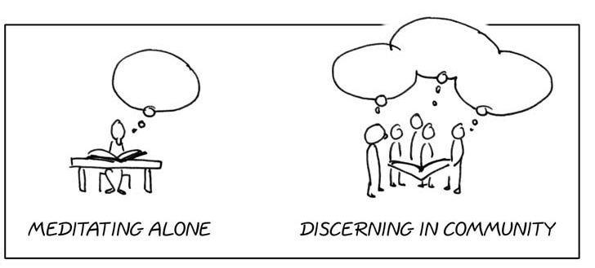
Dwelling in the word is inspired by lectio divina in its initial stages in that it is concerned with meditating on God’s word in the bible and letting it speak to us individually. However, it is a community discipline which helps us to discover and discern how God is speaking to us together.

How to dwell in the word
- Listen to the passage read.
- Read it to yourself again and notice what stands out to you. Consider where it ‘captures’ you, speaks to you and/or what question(s) it raises for you.
- Walk across the room to find a person in the group you do not know or know less well, a ‘reasonably friendly-looking stranger’. (On zoom, you may be put into breakout rooms.)
- Listen to that person as he or she tells you what they heard in the passage. Do not interrupt except for clarification. Listen attentively rather than discuss, because your job will be to report to a larger group of 4-6 what your partner has said, not what you yourself said. Some people take notes to help them focus and remember.
- Tell your partner what struck you in the passage and why.
- Join with another pair and report what your partner shared with you.

Further Notes & acknowledgements
This discipline was developed by Partnership for Missional Church as a way of helping whole communities experience how God’s word addressed their everyday lives and the illustrations above are taken from their resources. It starts with individual listening to the word. When we divide into pairs, our attentive listening without discussion helps even the quietest among us to express to others what we think God is saying to us. The requirement to share again what our partner told us, helps us to stop using others simply to confirm our own thoughts and practice the important discipline of listening. In the Partnership for Missional Church process, it is recommended that the passage used together is the same for a whole year together to enable deeper listening. (Luke 10.1-12 is usually the first passage used)

The Examen: Review of the Day
The Examen is a way of reviewing your day in the presence of God. It offers a method to reflect and let go at the end of the day. By reviewing the day that has passed and preparing for tomorrow with the expectation of God’s continued care, we create a habit of turning our lives over to God.
Ignatius of Loyola called this practice a direct gift from God and included it in his Spiritual Exercises. This simple, structured prayer time is a means of noticing grace and love in all parts of our day, public and private. Over time, the Examen can also assist us in discerning divine invitations – for example, the need to repent, or respond in new ways to God’s call.
It has four steps, which most people take more or less in order, and it usually takes 10 to 15 minutes per day:
- Ask God for light.
Find a private space and get comfortable. Invite God to guide you in remembering your day. Whatever your day has held, know that God’s love attends you as you look back.
I want to look at my day with God’s eyes, not merely my own.
- Give thanks.
As you review the morning, afternoon, and evening, notice moments of love and grace. Give thanks for the many gifts that you received, as well as the gifts that you shared. These don’t have to be big, dramatic gifts – you may notice simple moments that feel peaceful, joyous, or comforting.
The day I have just lived is a gift from God. Be grateful for it.
- Face your shortcomings.
Reflect on the times throughout the day when you made choices you regret or sinned by things ‘left undone’.

We fail to respond to God’s offer of love by failing to love God and to love our neighbour. Sin is the failure to bother to love. This realization leads us to sorrow; sorrow leads us to contrition and repentance—a turning toward God We are sinners, but we are always assured of God’s forgiveness and love.
I face up to what is wrong—in my life and in me.
- Look toward the day to come.
Ask for more of God’s light in the following day. Pray for God’s help in making different choices tomorrow. Bring your plans and hopes for tomorrow before God and ask God to be with you in all that the day holds.
I ask where I need God in the day to come.

References / Further reading
See: www.ignatianspirituality.com ‘The steps of the examen’ based on the Examen from ‘A Simple, Life-Changing Prayer by Jim Manney’ © Loyola Press
https://buildfaith.org/review-your-day-with-god/
Meditation
There are different forms of Christian meditation. This is one way of meditating based on the way taught by the World Community for Christian Meditation which you may find helpful:

1. As you prepare to be silent and still, you may wish to set a timer so that you are not watching the clock as you meditate.

2. Position yourself comfortably your back straight. Close your eyes lightly.

3. At the start of the Silence pray:

“Loving God, open our hearts to the silent presence of the Spirit of your Son.
Lead us into that mysterious silence where your love is revealed to all who call, 'Maranatha…Come, Lord Jesus”
John Main

4. Then in your head, silently begin to recite a single word – a prayer word. You could use the ancient Christian prayer "Maranatha" which means “Come Lord”: Ma-ra-na-tha. Say it as four equal syllables. Breathe normally and give your full attention to the word as you say it, silently, gently, faithfully and - above all - simply.

- Keep it simple. Stay with the same word during the whole meditation.
- Don't visualise but listen to the word, as you say it. Let go of all thoughts (even good thoughts), images and other words.
- Don’t fight your distractions: let the distraction go and by saying your word faithfully, gently and attentively and returning to it as soon as you realise you have stopped saying or it or when your attention wanders.

5. At the end of the silence, pray:

Gracious and Loving God,
give us wisdom to perceive you,
diligence to seek you,
patience to wait for you,
eyes to behold you,
a heart to meditate on you,
and a life to proclaim you,
through the power of the Spirit of Jesus Christ our Lord. Amen
Prayer of St Benedict

For more information on Christian meditation, see https://www.wccm.org/

Developing a Personal Rule of Life

The word “rule” conjures up images of school and dreary regulations. But a Christian “Rule of Life” is not that sort of thing. A “Rule of Life” is a framework for freedom – deliberately chosen habits and customs which we have chosen because they help us to live God’s way more closely. One of the most famous and far reaching Christian “rules of life” is that of the sixth century St Benedict of Nursia which remains the joyful heartbeat of the Benedictine Order to this day. This rule and many others were written in Latin: The Latin word “regula” means rule in the sense of a straight edge for measuring and drawing lines…. Like using a ruler to draw a straight line, it helps us to accomplish what we want without getting wobbly! The other meaning of the word “regula” is a regular rhythm – a chosen rhythm of life brings freedom rather than restriction, a practical way of seeking God more authentically and living more fully and joyfully for him. All growing Christian disciples have a rule of life although they may not know that this is what it is called.

A Rule of Life is an intentional pattern of spiritual disciplines that provides structure and direction for growth in holiness. A Rule establishes a rhythm for life in which is helpful for being formed by the Spirit, a rhythm that reflects a love for God and respect for how he has made us. The disciplines which we build into our rhythm of life help us to shed the “old self” and allow our “new self” in Christ to be formed. Spiritual disciplines are means of grace by which God can nourish us. Ultimately a Rule should help you to love God more, so if it becomes a legalistic way of earning points with God or impressing others, it should be scrapped. If the traditional, ancient term “rule” concerns you because it sounds legalistic, think of “rule” as a “rhythm of life” or as a “Curriculum in Christlikeness” (Dallas Willard), or as a “Game Plan for Morphing” (John Ortberg).

A rule of life will vary widely, depending on the character and life situation of a person. Not only will people choose different disciplines but how the disciplines are practiced will also be different.

Although every believer should pray, for example, the frequency or length or times or kind of prayer will differ. Thomas à Kempis writes, “All cannot use the same kind of spiritual exercises, but one suits this person, and another that. Different devotions are suited also to the seasons [of life]...”

It is helpful to include three areas:

1. Where you are now
2. What you will do
3. How you will be accountable

Here is a suggested way to do this:

1. Where I am now

Start by with a clear self-assessment that briefly describes your current situation in life–family responsibilities, work schedule, and other life circumstances. Your self-assessment should also reflect on the strengths and weaknesses of your character. Are you blessed, for example, with self-control, a compassionate heart, a bright mind, or a spirit of joy? Which vices do you most struggle with? It might be helpful to evaluate yourself in relation to the 7 deadly sins and their opposites:

Sloth Fruitfulness (not productivity)
Envy Love
Greed Generosity
Pride Humility
Anger Gentleness
Lust Chastity
Gluttony Self-denial, moderation

If you struggle with anger, for example, keep a journal for a week, noting what you get angry about and why, and rating each incident. Once you’ve identified a weakness, you can do something about it.

In general, talk over your self-assessment with someone who knows you well and ask for that person’s candid feedback. Beginning your Rule with an honest self-assessment will push you to develop a rhythm of life which is unique to your personality, circumstances, and needs.

2. What you will do (Spiritual Disciplines or Habits)

Second, describe the way in which you will practice specific habits or good disciplines.

Here is a list of some classic spiritual disciplines taken from the book “Celebration of Discipline” by Richard Foster. Your Christian life will probably include most of these but your Rule may focus on some a lot more than others

- Prayer,
- Meditation,
- Fasting,
- Study
- Simplicity,
- Solitude,
- Submission,
- Service
- Confession,
- Worship,
- Guidance,
- Celebration

This list is not exhaustive!

It is also helpful to include an explanation of why your choices not only fit your situation in life but also how they address areas where you especially need discipline and growth. In other words, describe how your Rule contributes to the goal of your spiritual formation, namely, being conformed to the image of Christ for the sake of others. Always remember this goal as you develop your Rule.

Making choices about specific disciplines requires prayer and wisdom. As you decide on specific practices (e.g. how and when to pray, serve, practice simplicity, etc.), consider the following questions:

a). What disciplines and specific practices are you attracted to and why you are attracted to them?

There is nothing wrong with choosing spiritual practices because they seem suited to your personality (e.g. an introvert may be drawn to more inward disciplines). You will likely engage in those disciplines with the greatest consistency and satisfaction. They may not, however, be the practices that will stretch you toward the greatest growth or the ones you most need. Still, they are probably a good place to start, especially if you have little spiritual discipline in your life at the moment.

b) Where do you sense that God is calling you to stretch and grow? Where do you want to change?

c) What kind of balance do you need in your life?

Does your Rule exercise your thoughts, actions, and affections (head, hands, and heart)? Does your Rule contain both corporate and individual practices? Both inward and outward disciplines? Don’t be confused by the title “Personal Rule of Life.” It’s a “Personal Rule” (as compared to a communal Rule) because it’s drawn up by you, it’s about you, and you are the one committing yourself to it. “Personal Rule” does not mean that you only engage in inward disciplines or private disciplines. Your personal Rule should include corporate disciplines (such as worship, confession, celebration, or spiritual direction) and outward disciplines (such as service, simplicity, or chastity).

d) If you could hear your own eulogy, what would you want to hear?

e) Is your Rule realistic for you to commit to?

A Rule is not a load of things you must add onto an already busy life. The disciplines you choose should not only be realistic for your life but should also balance, help to prioritise, interweave, and impregnate your entire way of life, better enabling you to take your ordinary life–your sleeping, eating, going-to-work, and walking-around life–and place it before God as an offering [Rom. 12:1, The Message].

How you will be
Once you have chosen your spiritual disciplines and explained your choices, you could state the name of the person who will hold you accountable and pray for you as you practice your Rule. For this role, consider a friend, a small group, or a spiritual director. Spouses and other family members should know enough of your Rule to be able to encourage, or at least not interfere needlessly with, your practice. However, it may be unwise to expect your spouse to be the only person holding you accountable in your spiritual life. The person(s) holding you accountable should also help you to discern when your Rule needs to be re-assessed and adapted.

Resources
Used in these notes
- Rule of St Benedict, Translation Mucknell Abbey 2002
- Rule of St Benedict, Ampleforth 1997 (ISBN 0 85244 435 4)
- Mucknell Abbey website: https//mucknellabbey.org.uk/
- Br. Stuart, On the Life : https//mucknellabbey.org.uk/vocation-stuart
- Chittister, Joan, The Rule of St Benedict Insight for the Ages, St Pauls, 1992 (A good, very accessible commentary on the Rule)

Further Reading on Spiritual Habits/ Disciplines
- Adams, Ian, Cave, Refectory, Road monastic rhythms for contemporary living, Canterbury Press 2010
- Jamieson, Christopher OSB, Finding Sanctuary. Monastic Steps for everyday life, Weidenfeld & Nicolson, 2006
- Bonhoeffer, Dietrich, Life Together, SCM 1954 translated by J W Doberstein
- John Mark Comer, Ruthlessly Eliminate Hurry from Your Life
- Dallas Willard, Spirit of the Disciplines
- Richard Foster, Celebration of Discipline
- Patrick Keifert, We are here now: a new missional era, Allellon Publishing (2006)
- Charlie Mackesy, The Boy, The Mole, The Fox and the Horse, Ebury Press (2019) (source of the illustrations in the course – a picture story book of wisdom speaking of the importance of love, friendship and kindness even in the midst of storms.)

Websites
www.light-wave.org
https://worthabbey.net/spiritual-resources/the-wisdom-of-humility
https://www.charliemackesy.com/

